MALICE
Compressor / Gate Board — ±15 V
Technical Design Guide, Rev 2
Item | Value
Board | Malice Compressor, 60 mm wide, 6-layer (signal / GND / −15V_A / +15V_A / GND / signal), 1.2 mm
Schematic / netlist | Compressor.net, export 2026-10-02, plus the Rev 2 as-built changes in §11
Supply | +15 V / −15 V from the Reactor PSU via J3 / J2 through 47 Ω (R15 / R43); ground on J4 / J5
Function | VCA compressor (feed-forward or feedback sidechain) with wet/dry blend, followed by a two-threshold VCA gate/expander and output level stage
Core devices | SSI2162 dual VCA (U9); OPA2191 ×6, OPA191, TL071
Controls | 13 trimmer pots, 2 solder jumpers, 3 test points, gain-reduction LED output
Document date | 25 October 2026 (Rev 2; supersedes 3 October 2026)
Status | Rev 1 board, bench-validated 21–24 October 2026 after the fault in §10 was cleared; this document describes the netlist as exported with the as-built deviations listed in §11

1. Overview
The compressor/gate board sits after the drive stages of the Distortion Studio. It is intended as a factory-set polishing compressor, studio-style glue after distortion rather than a sustainer, followed by a gate that can key either from the compressed signal or from the clean guitar signal supplied by the high-pass board. Both functions are built on one SSI2162 dual VCA: channel 1 is the compressor, channel 2 is the gate. The board runs on the ±15 V rails with the signal referenced to ground; there is no virtual-ground node anywhere on it.
Every control is a trimmer on the board. The design philosophy for the whole pedal, too much of everything at full rotation with a clear sweet spot, applies here: the ranges below are deliberately wider than a finished preset needs, and the model in §4–§6 together with the measurements in §9 is the map for choosing the preset.
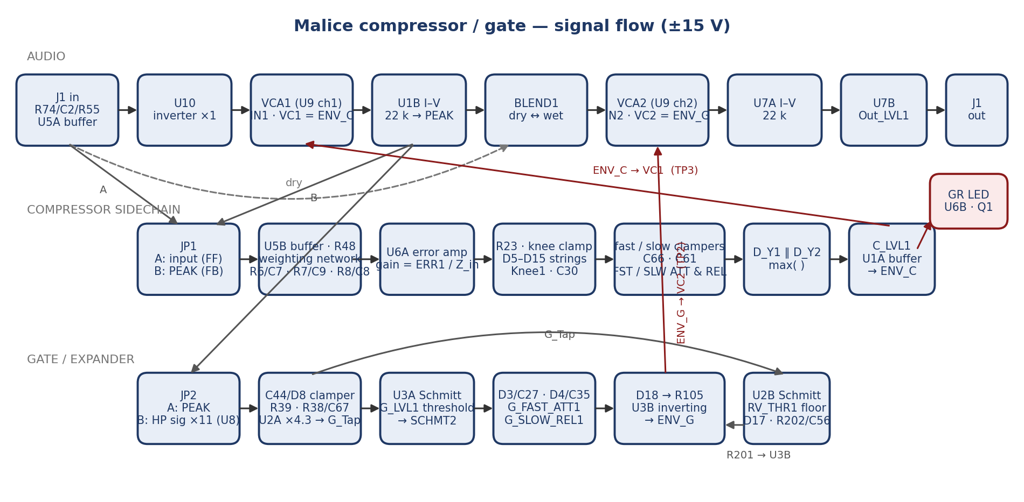
Figure 1 — Signal flow. Top: audio path. Middle: compressor sidechain producing ENV_C. Bottom: gate sidechain producing ENV_G. Both control voltages are measured at test points.

1.1 Key numbers
Parameter | Value | Where it comes from
Audio path gain, compressor at rest | 0 dB to PEAK; −33 dB to +12.6 dB after Out_LVL1 | U5A ×1, U10 ×−1, VCA ×1 at VC = 0, U1B 22 k I–V, U7B gain (Out_LVL1 + 100 Ω) / 4.7 k
Input high-pass corner | about 6 Hz | C2 220 nF into R74 + R55 + R33 ≈ 113 k
VCA control law | −33 mV/dB; 0 V = unity; +1 V = −30 dB | SSI2162 datasheet
Maximum compressor gain reduction | about 37 dB (hard knee, full depth) | 1.8 V knee clamp − 0.3 V diode, × 0.82, × 30.3 dB/V
Sidechain gain, HF plateau | 0 to +16.6 dB (ERR1) | ERR1 (0–50 k) / 7.4 k weighting-network input impedance
Compressor fast attack / release | about 5–30 ms / 27–50 ms (Rev 2) | C66 470 nF with FST_ATT1, FST_REL1, plus the two-pole ENV_C smoother (§3.5)
Compressor slow attack / release | 35–363 ms / 190–360 ms | C61 3.3 µF with SLW_ATT1, SLW_REL1
Gate attack / release | 1–48 ms / 47–520 ms | C35 470 nF with G_FAST_ATT1; C27 4.7 µF with G_SLOW_REL1
Gate depth (closed) | about −85 dB | U3B drives ENV_G to about +2.8 V (measured +3.4 V, see §11)
Gate thresholds | 0.045–1.40 V at the comparators; about 0.31–0.78 V peak at the detector | RV_THR1 / G_LVL1 dividers, BAT54 clamper, U2A ×4.3
Gate detector gain from the HP board | ×11 (+20.8 dB) | U8: 1 + 10 k / 1 k
Supply current | about 8–10 mA per rail (measured whole pedal 0.148 A at 9 V) | 7 op-amp packages + SSI2162 + TL071
Measured compression (Rev 2, feedback, ERR1 50 %) | 6 dB at 1.4 V peak in, 16.5 dB at 13 V; effective ratio 2:1 to 2.3:1 | §9

2. Audio path
Signal enters at J1 pin 1 (SigIn) through R74 (8.2 k) and C2 (220 nF) into R55 (4.7 k) and U5A, a unity-gain buffer with R33 (100 k) setting the input to ground. The buffered signal, Audio_In, feeds three places: the dry end of BLEND1, the feed-forward input of the sidechain jumper JP1, and U10.
U10 (OPA191) is an inverting unity stage (R111 / R112 10 k, C36 100 pF) whose only job is phase: the VCA's current-output I–V converter (U1B) inverts, so inverting once more ahead of the VCA keeps PEAK in phase with Audio_In for the blend. U10 drives the SSI2162's IN1 (pin 2) through R68 (22 k); R116 (110 Ω) and C80 (2.2 nF) are the input-node stabilisation network the SSI2162 datasheet specifies (confirmed against the datasheet in Rev 2; the single-channel SSI2161 sheet quotes different values and does not apply). OUT1 (pin 4) is a current, converted by U1B with R81 (22 k) and C19 (100 pF) to the voltage node PEAK. With equal 22 k input and feedback resistors, the compressor channel is unity gain at VC1 = 0. The SSI2162 input is rated for about 1.9 mA peak; at the drive's ±13 V rails the board puts 0.6 mA into it, well inside.
BLEND1 (10 k) pans between Audio_In (pin 1) and PEAK (pin 3); the wiper goes through R69 (22 k) into IN2 (pin 9) of the second VCA, with R117 / C81 as its stabilisation network. OUT2 (pin 7) is converted by U7A (R85 22 k, C48 82 pF) and goes through R60 (4.7 k) into U7B, an inverting stage whose feedback is Out_LVL1 (20 k, wiper tied to one end) in series with R62 (100 Ω): gain = (Out_LVL1 + 100 Ω) / 4.7 k, from −33 dB to +12.6 dB (Figure 9). R42 (100 Ω) and C39 (100 pF) isolate the op amp from the cable; R58 (1 k) sets the output impedance at J1 pin 2.
Every roll-off in the audio path is far above the band: U10 at 160 kHz, the VCA input networks at 660 kHz, the I–V stages at 72 and 88 kHz, the output network at 16 MHz. The board is flat to 20 kHz; any dullness heard through it is dynamic (gain reduction acting on bright transients), not filtering.

3. Compressor sidechain

3.1 Source select and buffer
JP1 selects the sidechain source: position A takes Audio_In (feed-forward), position B takes PEAK (feedback). The netlist ships it bridged 1–2, i.e. feed-forward; the board is now set to B (feedback), bar cut (§7, §10). Either way the signal passes through R86 (22 k) into U5B, a unity buffer loaded to ground by R31 (47 k), and leaves through R48 (1 k) into the weighting network.

3.2 Frequency weighting
Three series R–C–R branches run from R48's node into U6A's summing junction: R6 10 k / C7 470 nF / R5 3.3 k (corner ≈ 25 Hz), R7 22 k / C9 47 nF / R1 2.2 k (≈ 140 Hz) and R8 47 k / C8 6.8 nF / R12 4.7 k (≈ 450 Hz). In parallel they present ≈ 7.4 k above 1 kHz and a rising impedance below, so the sidechain sees the midrange and treble at full weight and the bass progressively less. That is the network that was rebalanced to stop pick transients from driving the deepest compression; Figure 2 shows the result.
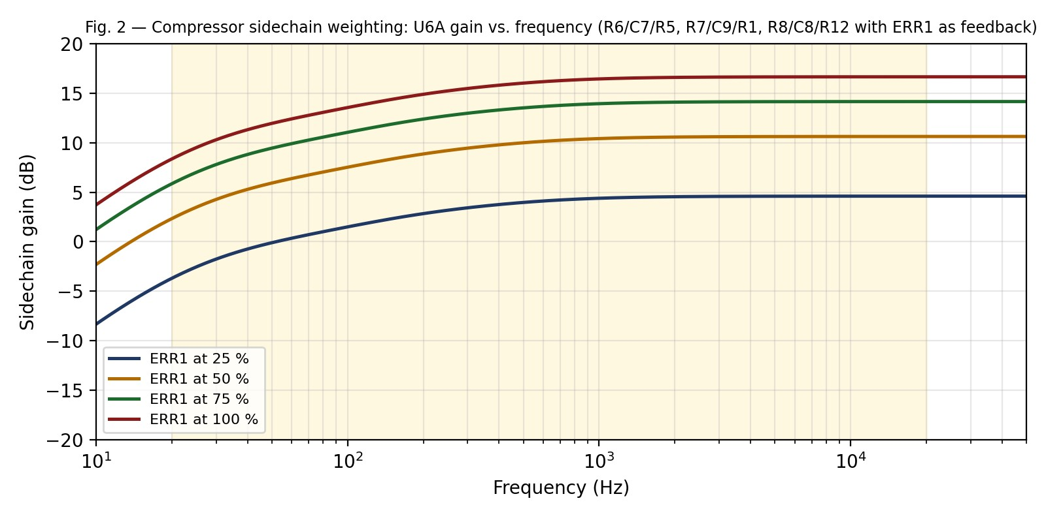
Figure 2 — Sidechain gain versus frequency for four ERR1 settings. The plateau above ~1 kHz is ERR1 / 7.4 k; the roll-off below is the three-branch network.

3.3 Error amplifier and ERR1
U6A is an inverting amplifier with its non-inverting input at ground and ERR1 (50 k, wiper tied to one end) as its feedback resistor, so its gain is ERR1 / Z_in(f). At 0 Ω there is no sidechain signal and no compression; at 50 k the plateau gain is ×6.8 (+16.6 dB). R91 (1 M) holds the summing node at DC. R10 / C11 (10 k, 3.3 nF) runs from the summing node to ground: because that node is a virtual ground it does not shape the sidechain's signal response, only the amplifier's noise gain, and it should stay at 3.3 nF (a Rev 2 proposal to raise it for high-frequency de-emphasis was withdrawn on that basis). ERR1 is the control that most people would call ratio or sensitivity: it sets how large the error signal is for a given input, and therefore how much gain reduction a given level produces. As built, ERR1 runs backwards: clockwise reduces the gain (§7).

3.4 Knee clamp
U6A's output passes through R23 (3.3 k) to the node Loop_ERR (TP1). Between Loop_ERR and the Knee1 / C30 node sit two anti-parallel strings of three 1N4148s. C30 (10 µF, with C45 100 nF and R72 22 Ω to ground) holds its node near 0 V, so the strings clamp Loop_ERR at roughly ±1.8 V: below that the error passes untouched; above it, the excess is shunted through Knee1 (0–5 k) and R23 into C30. With Knee1 at 0 Ω the clamp is hard and the maximum gain reduction is capped sharply; at 5 k the excess is divided ≈ 5 k / (5 k + 3.3 k) and the cap is approached gradually. Measured: TP1 at ±1.0 V with 15 mV into the pedal and about ±2.0 V with 90 mV (Figure 12). As built, Knee1 at fully clockwise is 0 Ω (hard).

3.5 Envelope detectors — fast and slow
Loop_ERR is still an audio-rate signal. Two clamper circuits turn it into envelopes. The fast path couples through C66 (470 nF) to the node D_Y1-A; when that node swings below ≈ −0.3 V, the path FST_ATT1 (0–50 k) → D7 → R71 (4.7 k) from the ground-referenced C46 / R73 node pulls it back up, which charges C66 and shifts the node's DC level positive by the peak amplitude. That charging rate is the attack: τ ≈ (4.7 k + FST_ATT1) × 470 nF, 2–26 ms. The DC level decays through FST_REL1 (0–470 k) + R66 (100 k) back to Loop_ERR, in parallel with the output-network load (R29 10 k into R94 + C_LVL1 ≈ 122 k), which is why the release only ranges 27–50 ms. The slow path is the same structure scaled up: C61 3.3 µF, SLW_ATT1 (0–100 k) + R67 (10 k), SLW_REL1 (0–500 k) + R52 (100 k), giving 33–363 ms attack and 190–360 ms release.
D_Y1 and D_Y2 (BAT54) with R29 / R95 (10 k each) join the two envelopes into one node: it follows the larger of the two. That node is divided by R94 (22 k) and C_LVL1 (100 k to ground); the wiper delivers 0 to ≈ 82 % of it. Rev 2 smoother: Rev 1 smoothed the wiper with R25 / C41 (10 k, 100 nF). On the bench ENV_C carried about 50 mV of ripple at the signal frequency, which modulates the VCA within each cycle (harmonic distortion on a note, intermodulation on a chord). A single 1 µF at C41 removed it but, because the source impedance is R94 plus the pot plus R25 (about 32 kΩ), it added about 32 ms of lag to both attack and release. The fitted solution is two poles: C41 back to 100 nF and a 220 nF from C_LVL1 pin 1 to ground. Modelled with the pot loading included, that gives 44 dB of rejection at 1 kHz with C_LVL1 at full depth (55 dB at mid) and a 26 Hz corner (about 6 ms), against 45 dB and 5.7 Hz (28 ms) for the 1 µF; 100 nF + 100 nF was rejected at 38 dB. The buffered result is ENV_C (TP3), driving VC1 through R98 (47 Ω). C_LVL1 scales the whole envelope and therefore the whole transfer curve without changing where it starts; as built it runs backwards: clockwise reduces depth.

3.6 Gain-reduction indicator
U6B with four 100 k resistors is a unity differential amplifier comparing ENV_C with the voltage across R_E1 (100 Ω) in Q1's emitter; it drives Q1's base through R_B1 (10 k). The result is a voltage-to-current converter: LED current = ENV_C / 100 Ω, so 1 V of control voltage (30 dB) lights the LED at 10 mA; the ceiling is about 15–20 mA with the envelope pinned. The LED cathode returns through J7 to the main board, where the two red indicator LEDs are fed from the 9 V side through Q3 and a 220 Ω. This path draws nothing from the ±15 V rails and cannot account for supply-current problems; it was examined and cleared during the October fault-finding.
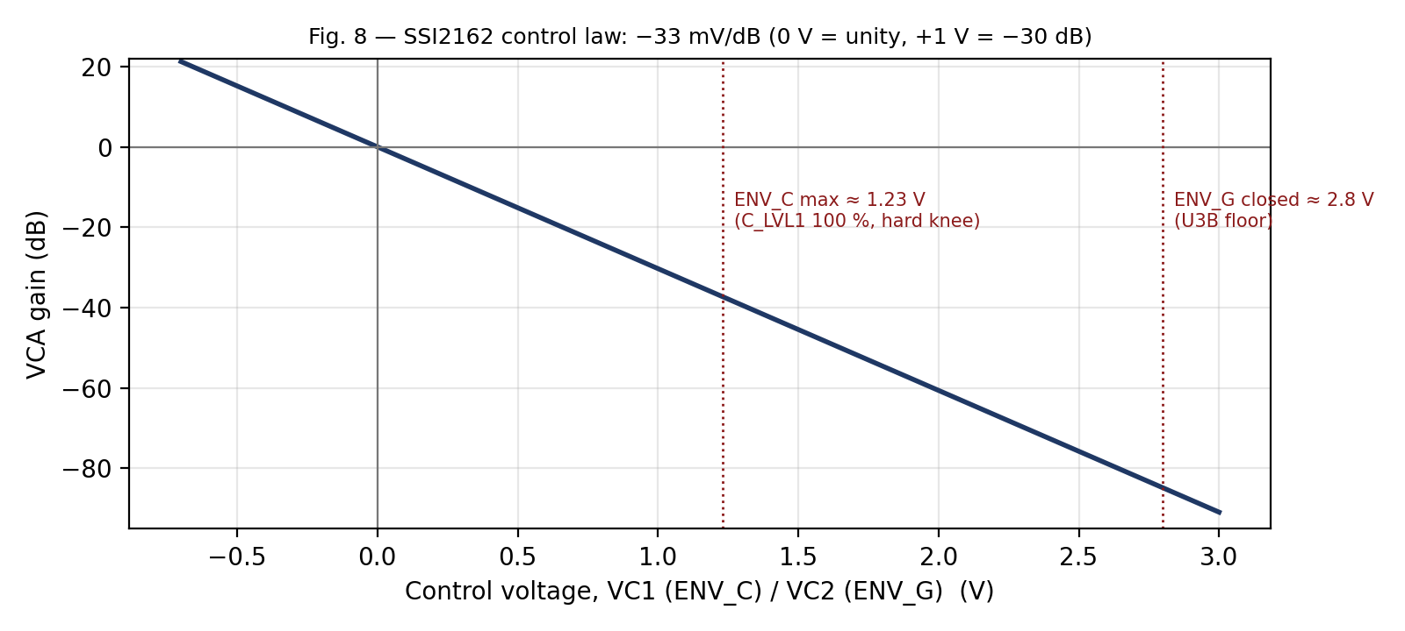
Figure 8 — The SSI2162 control law, with the two operating points that matter: the compressor's maximum ENV_C and the gate's closed ENV_G.

4. Static response
The detector is linear-domain: the envelope is proportional to signal amplitude, not its logarithm, and the VCA is exponential (dB per volt). Gain reduction in dB is therefore proportional to the input amplitude in volts. On a dB-versus-dB plot that produces a curve whose slope steepens continuously, a soft knee that keeps getting harder, until the knee clamp caps it. Figure 3 shows the model for both sidechain topologies; Figure 4 shows the same thing as gain reduction versus input; §9 shows what the board actually measured.
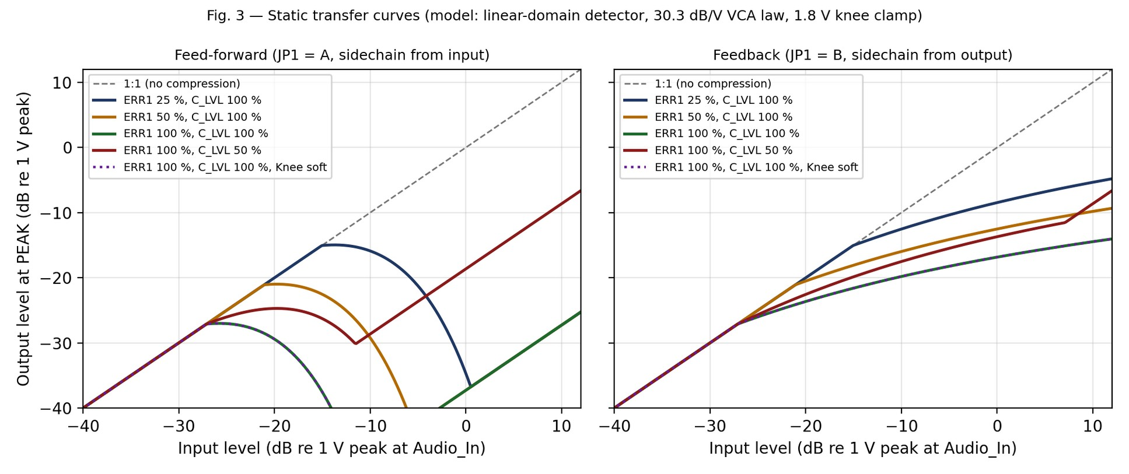
Figure 3 — Modelled static transfer, output at PEAK versus input at Audio_In. Left: feed-forward. Right: feedback. Levels in dB relative to 1 V peak.
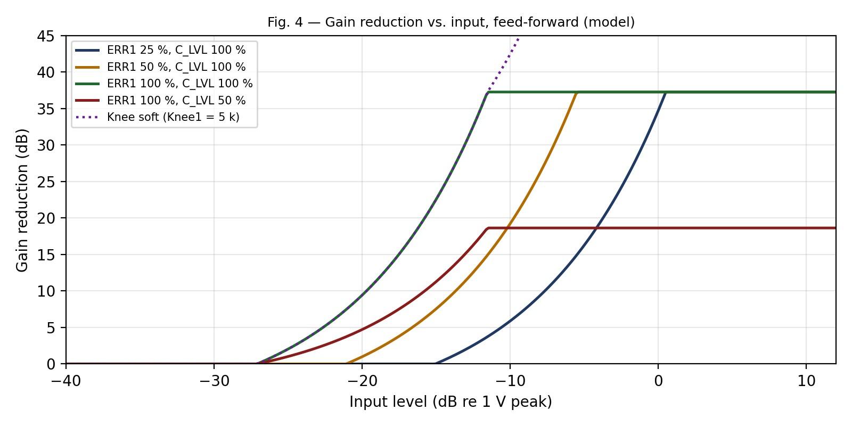
Figure 4 — Gain reduction versus input level, feed-forward. The flat tops are the knee clamp; the dotted curve is Knee1 at 5 k.
Feed-forward over-compression. Because gain reduction grows linearly with input voltage, the feed-forward curve has a turnover: above about 50 mV peak (ERR1 and C_LVL1 at full), each extra dB of input produces more than a dB of gain reduction and the output level falls until the clamp is reached. In this pedal the compressor is fed by the drive stage at volts, not millivolts, so in feed-forward mode the detector is at its ceiling for almost any playing level; that was part of the "nothing I adjust helps" complaint before Rev 2. In feedback mode the loop finds its own balance and the curve becomes a conventional soft-knee limiter with an effective ratio that rises from about 2:1 at the knee toward 4:1: the behaviour a studio-glue setting wants, and the mode the board is now set to.
Approximate model, 1 kHz: gain reduction (dB) ≈ 30.3 × k × max(min(G × A, 1.8 V) − 0.3 V, 0), where k = C_LVL1 depth fraction × 0.82, G = ERR1 gain fraction × 6.8, and A is the peak amplitude at the sidechain source in volts. For feedback mode A is the output amplitude, solved iteratively.

5. Dynamic response
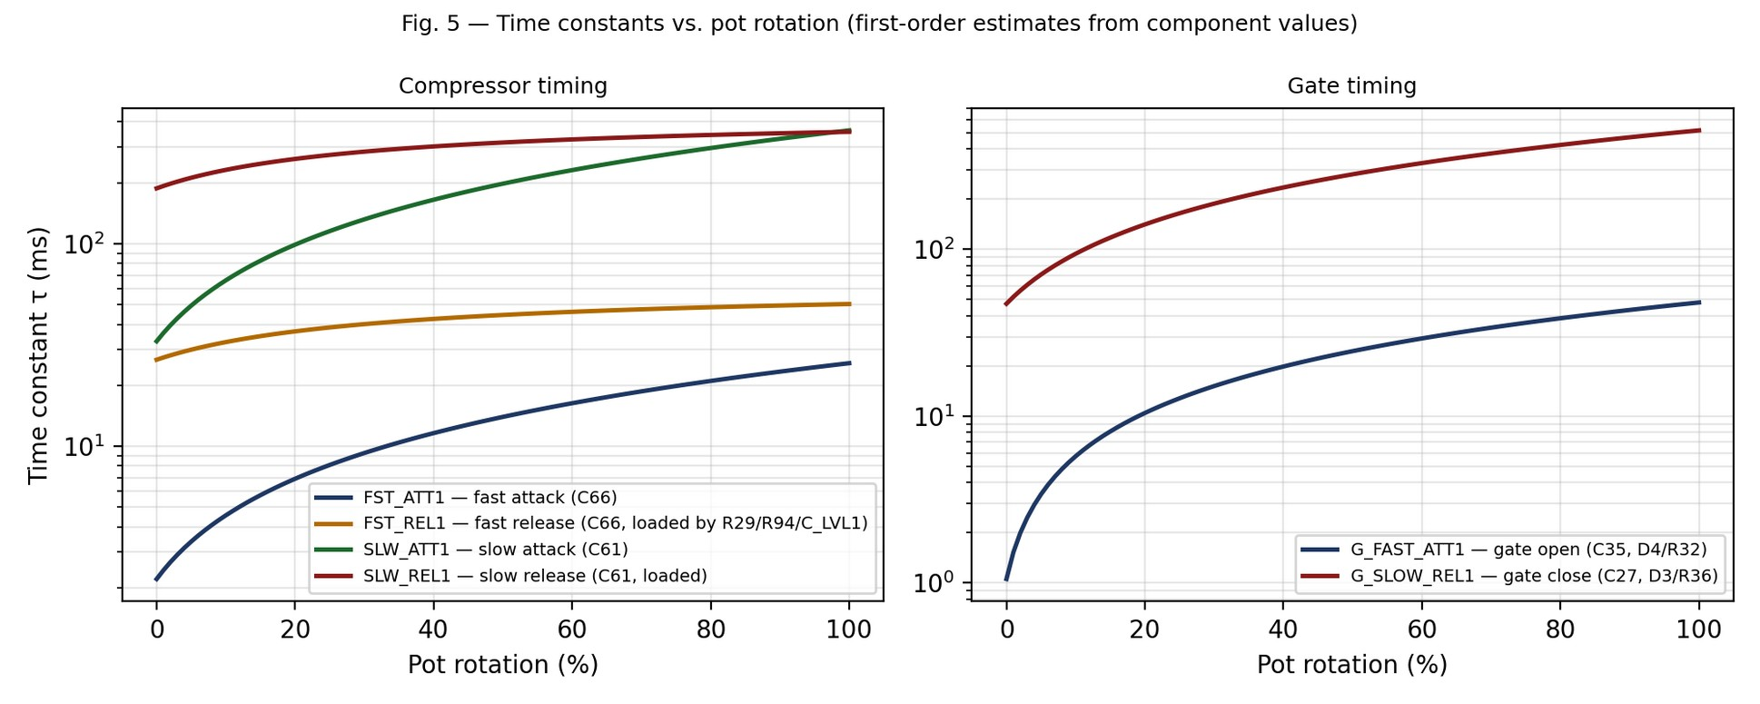
Figure 5 — Time constants versus pot rotation for the four compressor timing pots and the two gate timing pots (Rev 1 model; the Rev 2 smoother adds about 6 ms to the compressor attack and release). Log scale.
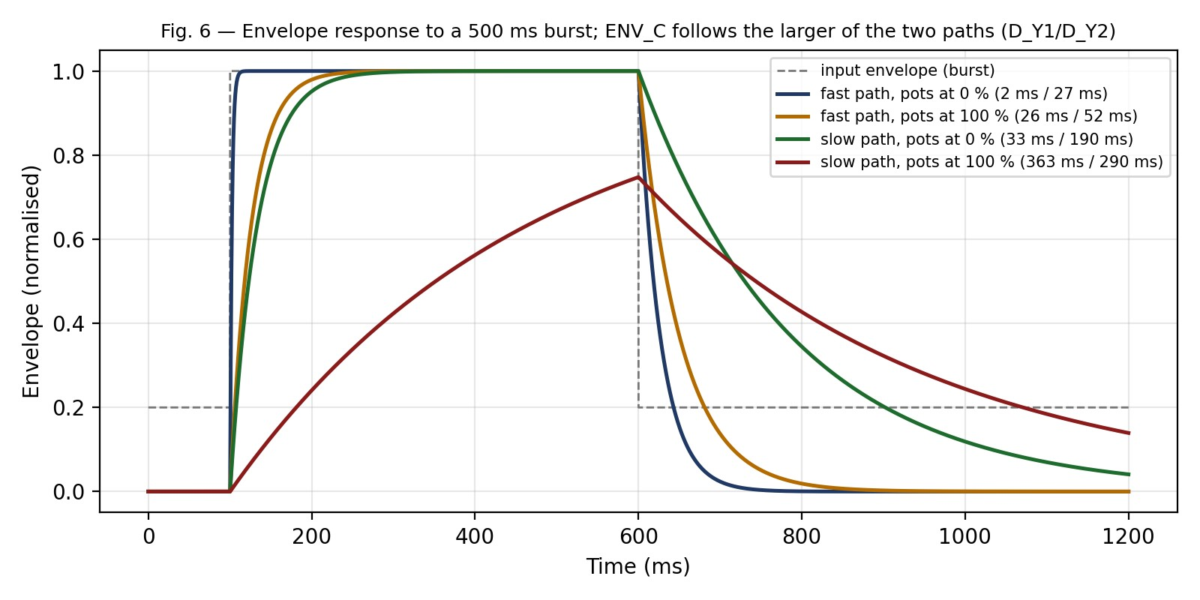
Figure 6 — Illustrative envelope response to a 500 ms burst for the fast and slow paths at their pot extremes. ENV_C follows whichever path is larger, so the fast path shapes the attack and the slow path holds the tail.
Reading the two paths together: the fast path gets to the envelope within a few milliseconds and lets go within tens of milliseconds, so on its own it tracks individual notes. The slow path takes 35 ms to 360 ms to arrive and 200–360 ms to leave, so it rides the phrase. Because the diode-OR takes the larger of the two, the fast path handles the attack of every note while the slow path keeps the gain from pumping back up between notes. Setting the slow attack long and the fast attack short gives a compressor that catches transients but doesn't breathe; setting both short gives a peak limiter.
The release pots are weaker than their values suggest. FST_REL1 at 470 k would give a 268 ms release on C66 alone, but the envelope node is permanently loaded by R29 into the C_LVL1 network (≈ 132 k), so the achievable fast release is 27–50 ms. The same load limits the slow release to ~360 ms instead of 2 s. If a longer release is wanted in a future revision, the fix is a buffer or a higher-value R29 / R95, not a larger pot.

6. Gate / expander

6.1 Detector
JP2 selects the gate's key signal: position A (pads 1–2, factory bar) is PEAK, the compressed signal; position B (pads 2–3) is the clean guitar signal from the high-pass board at J10. That signal is first amplified by U8 (TL071) as a non-inverting ×11 stage (R11 10 k, R13 1 k) and leaves through R14 (100 Ω) as HP_SIG. The board is now set to B, bar cut; this requires the J10 wire from the main board's TO_COMP tap, without which the gate never opens.
The selected signal couples through C44 (470 nF) to a BAT54 clamper (D8, anode to ground) that holds the negative peaks at ≈ −0.3 V, so the node's DC level equals the peak amplitude minus the diode drop. R39 (470 k) bleeds it (τ ≈ 220 ms), R38 / C67 (100 k, 100 nF; 16 Hz) smooth it, and U2A amplifies it by 1 + R35 / R28 = ×4.3 to produce G_Tap. Nothing below ≈ 0.3 V peak at the detector can register, which is one reason the HP path has gain. Note that this detector has one 16 Hz pole of smoothing where the compressor now has two; its ripple is an open item (§12).

6.2 Two thresholds
Both threshold pots are 100 k trimmers in the same divider: 3.3 k to ground at one end, 1 M to +15 V at the other, so the wiper covers 0.045 V to 1.40 V (Figure 7). G_LVL1 sets the gate threshold at U3A, a Schmitt trigger comparing 0.69 × G_Tap (R93 / R88 divider) with the pot, with R104 (1 M) giving ≈ 0.28 V of hysteresis. RV_THR1 sets a second, lower-level floor at U2B, comparing G_Tap directly with ≈ 0.13 V of hysteresis from R_HYS1 (2.2 M). Both comparators were given deliberate margin from zero so that they release; a threshold at exactly 0 V was found to latch.
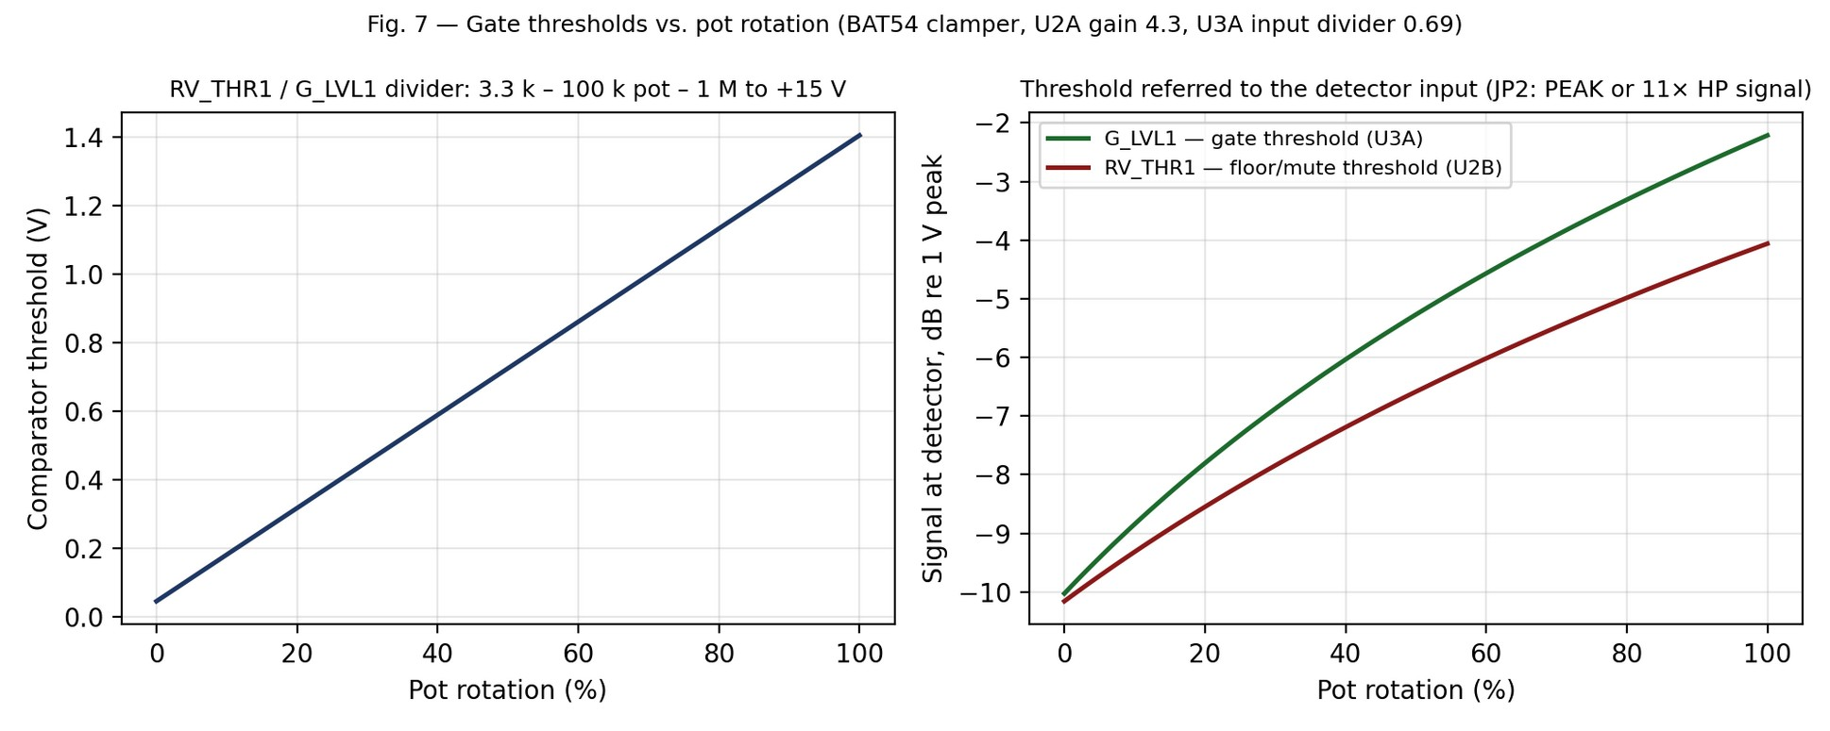
Figure 7 — Threshold voltage versus pot rotation (left) and the equivalent peak signal level at the detector input (right), including the 0.3 V clamper floor.

6.3 Timing
U3A's output (±14 V) leaves through R108 (47 Ω) and R107 (1 k) as SCHMT2 and drives two R–C–diode legs. The attack leg: R90 (1 k) → R32 (2.2 k) → D4 into C35 (470 nF), whose other end goes through R76 (47 Ω) and G_FAST_ATT1 (0–100 k) to ground, so when SCHMT2 goes high, C35 charges with τ = (2.2 k + 47 + G_FAST_ATT1) × 470 nF, 1–48 ms, and R19 (1 M) bleeds it. The release leg: R18 (47 k) charges C27 (4.7 µF) slowly while the gate is open; when SCHMT2 goes low, D3 and R36 (10 k) discharge it with τ = (10 k + 47 + G_SLOW_REL1) × 4.7 µF, 47–520 ms. The two capacitor nodes are summed by R109 / R110 (10 k each) at D18's cathode. As built, both gate timing pots run backwards: clockwise is faster.

6.4 Control voltage
U3B is an inverting stage with its summing junction at virtual ground, R115 (6.8 k) and C38 (100 nF) as feedback. It receives two currents. From D18 → R105 (47 k): the timing node, whenever it is more than ≈ 0.3 V below ground. From R201 (33 k): the floor stage: when U2B's output goes low (signal below RV_THR1), D17 pulls the R202 / C56 node (10 k, 2.2 µF; 22 ms) toward −14 V, and U3B turns that into ENV_G ≈ +2.8 V, which is ≈ −85 dB on the VCA. When the signal is above the floor, R201 lets the node recover toward 0 V with τ ≈ 73 ms. ENV_G leaves through R97 (47 Ω) to VC2 and is measured at TP2.
Measured closed-state ENV_G is +3.4 V, not 2.8. The SSI2162's −100 dB point is +3.3 V and its control-pin absolute maximum is the rails, so 3.4 V is not damaging; but with the gate closed and no signal the VCA's IN2 pin was seen drifting to −10 V, and it returned to 0 V as soon as the gate opened. Whether the two are linked is not established. R115 at 5.6 kΩ brings the closed state to the design's 2.8 V and is a reasonable bench trial; measure pins 8 and 9 through a gate open/close before and after.

7. Controls reference and rotation sense
Rev 1 stated "clockwise = more" for every control. The netlist shows the as-built wiring of the Bourns 3214 trimmers (clockwise moves the wiper toward pin 3) gives the opposite sense for seven of them, and the board behaved accordingly on the bench. The User's Guide Rev 2 gives every setting as a corrected percentage of clockwise travel; this table records the underlying facts. Next spin: swap pins 1 and 3 on the seven reversed footprints.
Control | Value | Wiring | Function | Range (model) | Clockwise (as built)
ERR1 | 50 k | rheostat, wiper tied to pin 1 | Sidechain gain | 0 to +16.6 dB | LESS (reversed)
C_LVL1 | 100 k | divider, pin 3 to ground | Compression depth | 0 to 82 % of envelope | LESS (reversed)
Knee1 | 5 k | rheostat, pin 3 to the cap | Knee hardness | 5 k soft to 0 Ω hard | HARDER (reversed)
FST_ATT1 | 50 k | rheostat, pin 3 to the cap | Fast attack | about 30 to 5 ms | FASTER (reversed)
FST_REL1 | 470 k | rheostat, wiper tied to pin 3 | Fast release | 27 to 50 ms | longer
SLW_ATT1 | 100 k | rheostat | Slow attack | 360 to 35 ms | FASTER (reversed)
SLW_REL1 | 500 k | rheostat, wiper tied to pin 3 | Slow release | 190 to 360 ms | longer
BLEND1 | 10 k | divider, pin 1 dry, pin 3 PEAK | Dry / wet | dry to wet | wetter
G_LVL1 | 100 k | divider, pin 3 side to ground | Gate threshold (U3A) | 0.31 to 0.78 V pk | higher (verify at TP2)
RV_THR1 | 100 k | divider, pin 1 side to ground | Floor threshold (U2B) | 0.31 to 0.63 V pk | higher (verify at TP2)
G_FAST_ATT1 | 100 k | rheostat, pin 1 to ground | Gate open | 48 to 1 ms | FASTER (reversed)
G_SLOW_REL1 | 100 k | rheostat, pin 1 to ground | Gate close | 520 to 47 ms | FASTER (reversed)
Out_LVL1 | 20 k | rheostat (U7B feedback) | Output level | −33 to +12.6 dB | louder
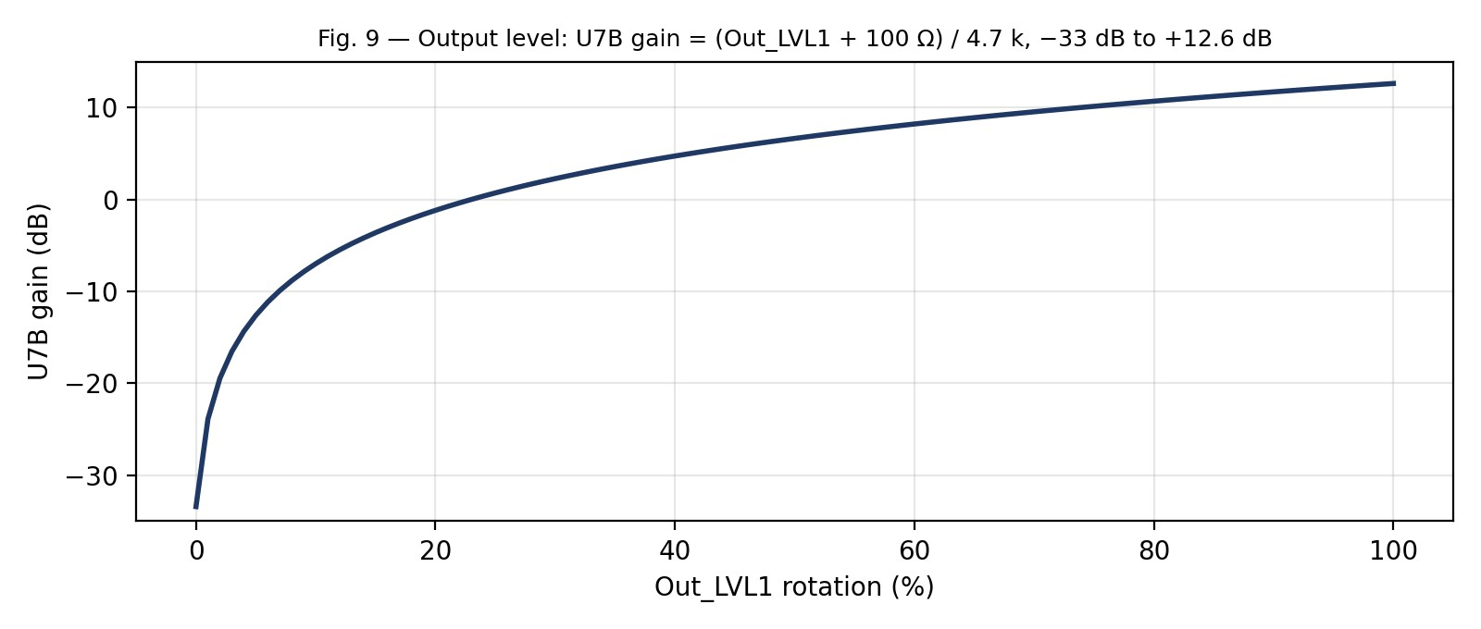
Figure 9 — Output stage gain versus Out_LVL1 rotation.
Jumpers. Both are SolderJumper-3 "Bridged12" footprints: a copper bar joins pads 1–2 as the default and must be cut before pads 2–3 are bridged; all three pads joined shorts two op-amp outputs (§10). JP1: 1–2 (A) = feed-forward sidechain from Audio_In; 2–3 (B) = feedback sidechain from PEAK. JP2: 1–2 (A) = gate keyed from PEAK; 2–3 (B) = gate keyed from the high-pass board's clean signal via U8. Both now at B. Connectors. J1 = signal in (pin 1) / out (pin 2); J2 = −15 V; J3 = +15 V; J4, J5 = ground; J7 = gain-reduction LED cathode return; J10 = clean signal from the high-pass board.

8. Test points and expected readings
Test point | Net | No signal | With signal | What it tells you
TP1 | Loop_ERR | ≈ 0 V DC | audio-rate error signal, clamped at about ±2 V on peaks (measured) | ERR1 is working; knee clamp level
TP3 | ENV_C | 0 V | 0 to ≈ +1.23 V DC, 33 mV per dB; measured 0.20 V at 1.4 V in, 0.55 V at 13 V in | compressor depth; attack/release on a scope
TP2 | ENV_G | ≈ +2.8 V design, +3.4 V measured (gate closed) | ≈ 0 V with signal above both thresholds | gate state; D18 and R201 paths
Supply check. +15V_A and −15V_A are the rails after R15 / R43 (47 Ω); expect about ±14.5 V with under 0.5 V across each resistor. The voltage across those two resistors is the fastest way to localise excess current to this board: 2 V across 47 Ω is 40 mA, and the board's legitimate draw is under 10 mA per rail. VCA pin check. With no signal, SSI2162 pins 2, 4, 7 and 9 should all sit within a few millivolts of 0 V; a pin at volts is being forced by the op amp around it and will make the chip run hot.

9. Bench measurements (October 2026)
All measurements with a Digilent Analog Discovery 3 (WaveForms), 1 kHz sine at the pedal's input jack, Dist at full (chain gain 39 dB: 15 mV in gives 1.4 V at the compressor input, 90 mV gives 8.2 V, 180 mV gives 13 V as the drive reaches its rails), compressor engaged, JP1 feedback, ERR1 50 %, C_LVL1 full depth, Knee mid, BLEND fully compressed, attacks slow, releases mid, gate open.
Pedal input (peak) | Compressor input (peak) | ENV_C (TP3) | Gain reduction (33 mV/dB) | TP1
15 mV | ±1.4 V | 0.20 V | 6 dB | ±1.0 V
30 mV | ±2.8 V | 0.30 V | 9 dB | —
60 mV | ±5.6 V | 0.41 V | 12.5 dB | —
90 mV | ±8.2 V | 0.44 V | 13.5 dB | ±2.0 V (clamp)
180 mV | ±13 V | 0.55 V | 16.5 dB | —
Each 6 dB step of input adds 3 to 3.5 dB of reduction: an effective ratio of 2:1 to 2.3:1, with ENV_C still climbing at the top of the range rather than parked. Residual ENV_C ripple at the higher levels about 40 mV peak-to-peak (about 1 dB of gain wobble) with the single 1 µF; to be re-measured with the two-pole smoother and with the probe ground on C41's ground pad rather than a distant point. Whole-pedal current 0.148 A at 9 V, unaffected by touching the boards.
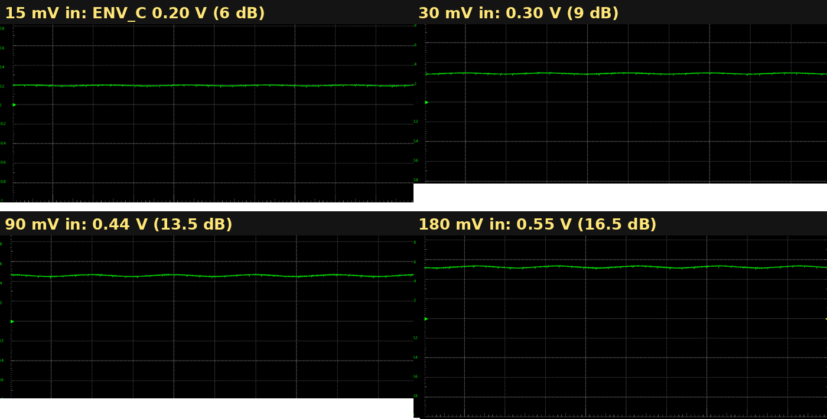
Figure 10 — TP3 (ENV_C) at 15, 30, 90 and 180 mV into the pedal, 200 mV/div.
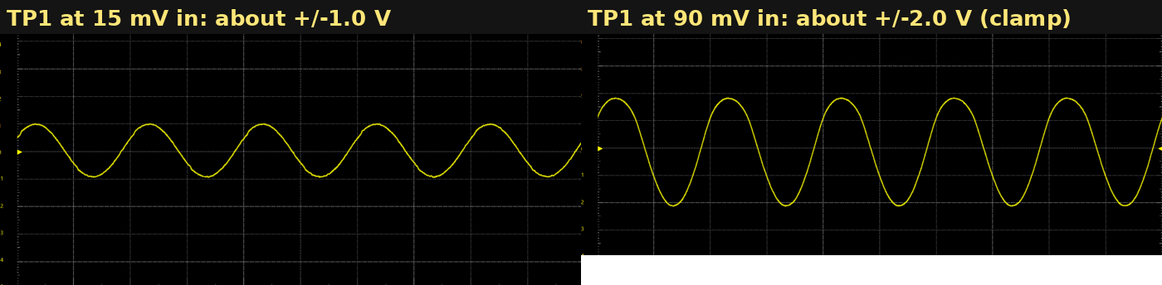
Figure 11 — TP1 (Loop_ERR) at 15 mV (about ±1 V) and 90 mV (about ±2 V, knee clamp reached), 1 V/div.
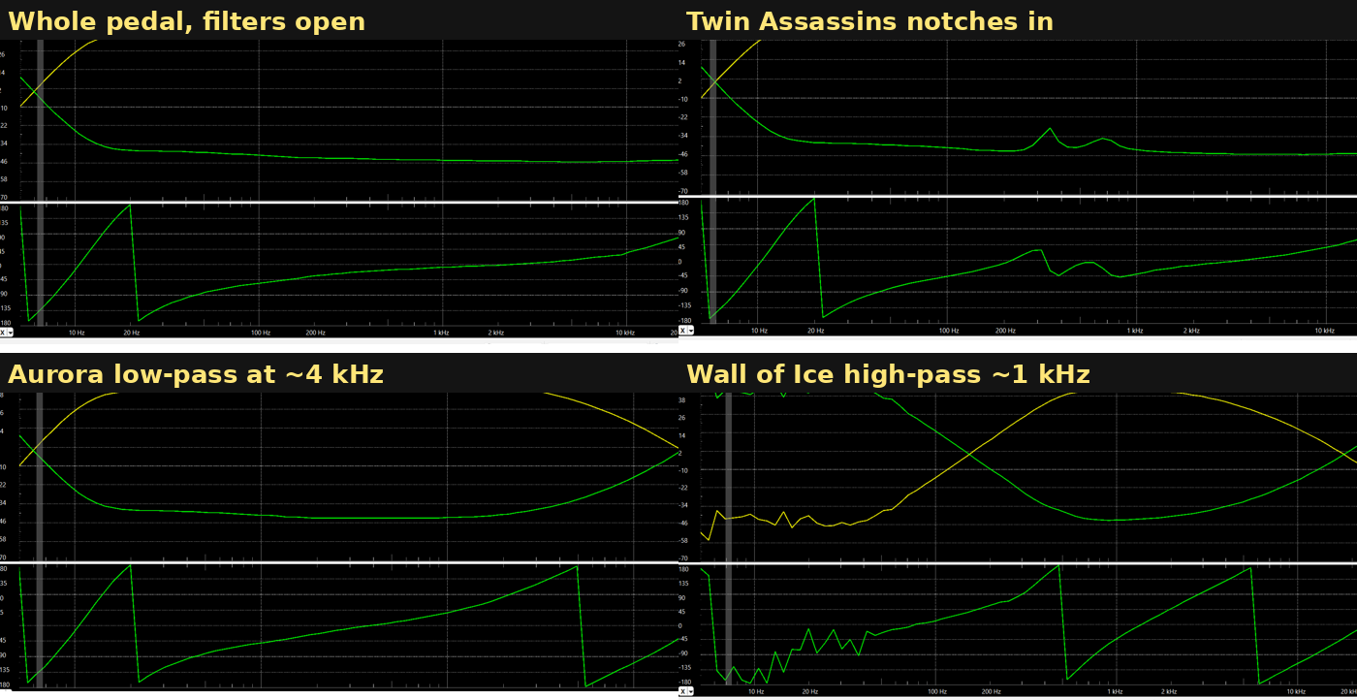
Figure 12 — Whole-pedal Bode plots (50 mV sweep, 5 Hz–22 kHz) for context: flat with the filters open, the Twin Assassins notches near 350 and 750 Hz, the Aurora low-pass at about 4 kHz, the Wall of Ice high-pass near 1 kHz. The compressor sits after the Aurora.

10. The October 2026 fault and what it taught
Symptoms: 0.45–0.47 A at the 9 V jack whenever a large signal was present (Dist above about 10 % with a sine, or a hard strum), the Reactor sagging to 12 V, the compressor board's rails at ±9 V (2–3 V across R15 and R43, i.e. 60 mA per rail), the SSI2162 and U5 warm, and a half-wave-rectified output at both 15 mV and 90 mV input (Figure 13). The intermittent 0.4 A episodes seen earlier, which came and went when boards were moved or op amps touched, were the same fault with a marginal joint.
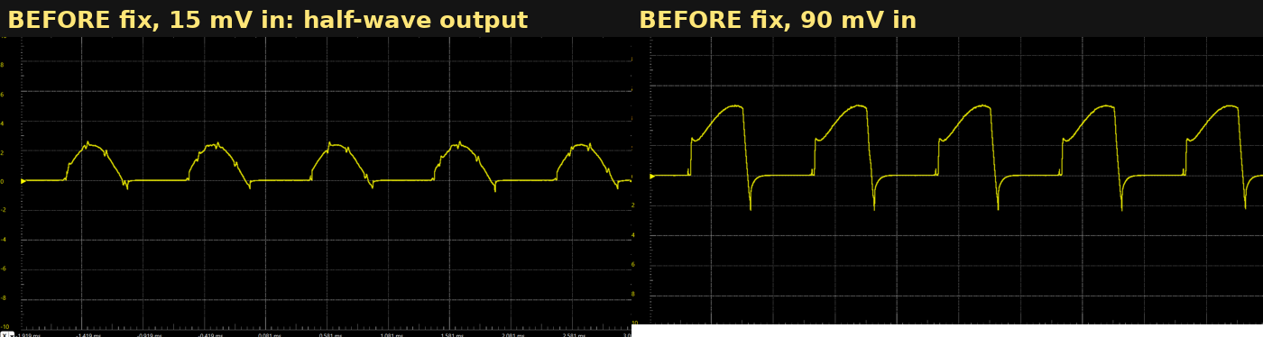
Figure 13 — Compressor output before the fix: negative half missing, sawtooth on the positive half at the higher level.
What was tried, in order, and what each ruled out: the indicator LEDs (fed from 9 V, ≤ 20 mA, not on the rails); the negative rail (present); mechanical joints (reflowed, no change; the fault was signal- and finger-sensitive, not pressure-sensitive); a PSU simply overloaded (the sag was across the board's own 47 Ω feeds); the VCA input networks (desoldered and measured good; the datasheet confirms 110 Ω / 2.2 nF); VCA input overdrive (0.6 mA against a 1.9 mA rating); the R60 treble-shelf bodge (lifted, no change); the SSI2162 (replaced, new one heated the same); U5 (replaced, briefly better, then the same); U10 (replaced, no change); the PCB (a geometry check of every pad, via and track against foreign nets, plus plane assignment, came back clean).
Root cause: both three-pad solder jumpers had solder across pads 2–3 with the factory 1–2 copper bar still intact, so all three pads were common on each. JP1 therefore shorted U5A's output (Audio_In) to U1B's output (PEAK); JP2 shorted U1B's output to U8's output (HP_SIG) through 100 Ω. With no signal every output sits at 0 V and nothing shows; with signal the outputs are at different amplitudes and each op amp fights to impose its own level, all of them in current limit, both rails loaded equally. U1B's summing node is dragged off ground, which forces the VCA's OUT1 pin and heats the chip. The ohmmeter check that finds it in seconds: U5 pin 1 to U1 pin 7 reads near 0 Ω instead of the BLEND pot's 10 kΩ. Clearing the solder restored 0.148 A, a clean output, and finger-proof behaviour; the bars were then cut and 2–3 bridged deliberately on both jumpers.
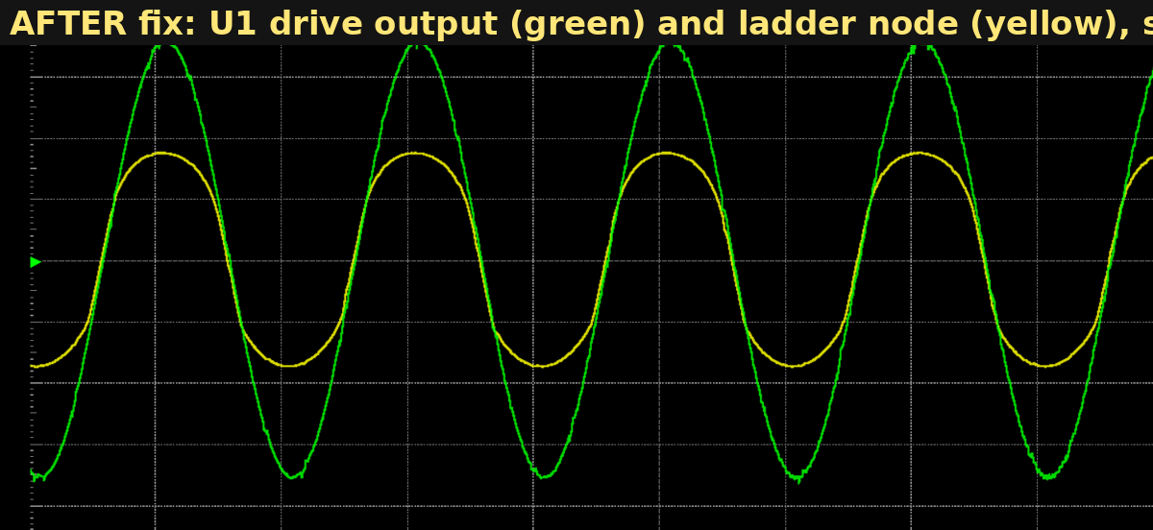
Figure 14 — After the repair: the drive output (green, ±6 V) and the ladder node (yellow) symmetric on both halves; the compressor passes a clean sine at every level.
Lessons recorded for the next engineer: a fault that needs signal, loads both rails, warms more than one chip and survives chip replacement is a short between outputs; measure output-to-output resistance before replacing parts. Rail-drop readings across the per-board 47 Ω resistors localise current to a board in seconds. DC readings on the VCA's signal pins separate "forced by the circuit" from "damaged". An AC-coupled scope capture of a rail with the fault present was never taken and would have distinguished oscillation from a short in one shot. Three-pad jumpers with a factory bar are a trap worth designing out.

11. As-built deviations from the netlist (Rev 2)
Reference | Netlist | As built | Why
JP1 | bar 1–2 (feed-forward) | bar cut, 2–3 (feedback) | glue behaviour with a post-drive signal; §4
JP2 | bar 1–2 (PEAK key) | bar cut, 2–3 (HP_SIG key) | gate follows the strings, not the drive; needs J10 wired
C41 | 100 nF | 100 nF (was 1 µF during fault-finding) | two-pole smoother; §3.5
C_LVL1 pin 1 to ground | none | 220 nF added (X7R or film, 0805) | first pole of the smoother; §3.5
R60 shelf (6.8 k + 4.7 nF across R60) | none | not fitted | a treble-restore bodge tried during fault-finding; removed; re-fit only if compressor mode is darker than bypass
C11 | 3.3 nF | 3.3 nF (restore if a 10 nF was fitted on 22 Oct) | virtual-ground stability shunt; raising it does not shape the sidechain
R115 | 6.8 k | 6.8 k (5.6 k proposed) | closed-gate ENV_G +3.4 V measured vs 2.8 V design; §6.4
U5, U9, U10 | — | replaced | renewed after hours at 40 mA/rail; none was the cause
R116/C80, R117/C81 | 110 Ω / 2.2 nF | unchanged | confirmed as the SSI2162 datasheet values

12. Open items
- Square-wave lean: a 1 kHz square at full Dist into the compressor shows the output tops leaning toward zero by 25–30 % within each half-cycle; it disappears in bypass and is still present with the two-pole smoother fitted (Figure 15). Next: capture TP3, TP2 and U1 pin 7 with that signal to see which control pin moves inside the cycle. The gate detector (one 16 Hz pole) is the leading suspect. Not audible on guitar at the Glue preset.
- Re-measure ENV_C ripple with the two-pole smoother and a local probe ground; read the ripple's frequency and size at the envelope node before R94 and at U1A's input and output.
- R115 5.6 k trial with pin 8 / pin 9 readings through a gate transition.
- Confirm the rotation sense of G_LVL1 and RV_THR1 at TP2.
- Next spin: flip the JP1/JP2 footprints (or use two-pad jumpers per mode) so the shipped modes need no knife; swap pins 1 and 3 on the seven reversed trimmers; consider a buffer or higher R29/R95 for longer releases; consider a second pole on the gate detector.
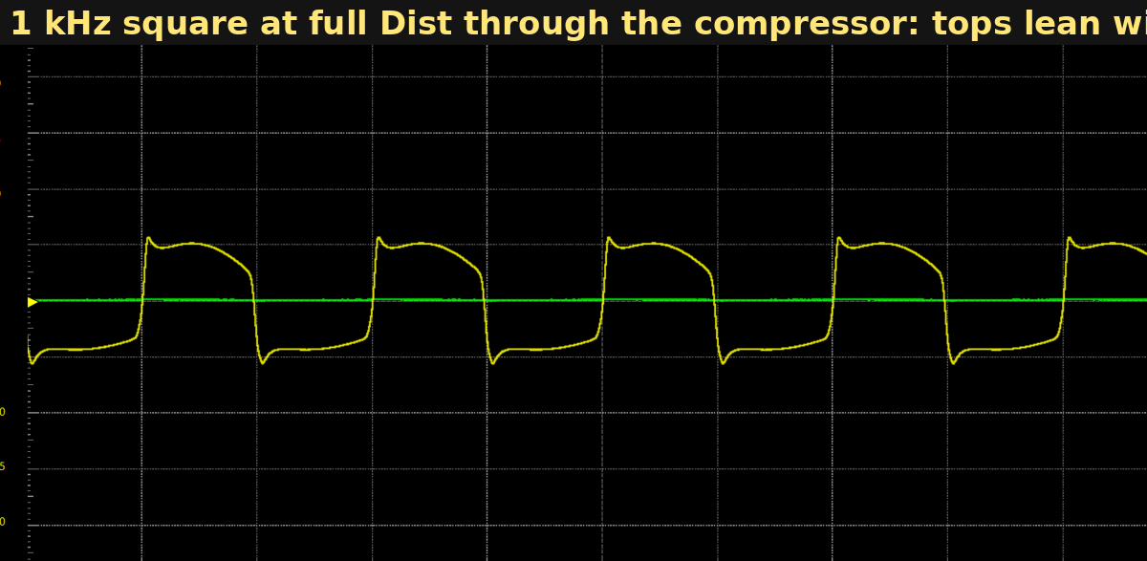
Figure 15 — Open item: 1 kHz square at full drive through the compressor, 5 V/div. The lean within each half-cycle is gain changing at the signal rate.

13. Model assumptions and what to verify on the bench
- VCA law taken as exactly −33 mV/dB with unity at 0 V; the SSI2162 datasheet gives ±1 dB-class tolerance and some temperature dependence. The §9 numbers use it.
- Diode drops: 0.3 V for the BAT54 clampers, 0.6 V per 1N4148 in the knee strings (1.8 V per string). The measured clamp at TP1 was about ±2 V.
- Time constants are first-order R–C estimates; the clampers are nonlinear and the attack in particular depends on signal frequency (the capacitor charges only on negative half-cycles). The Rev 2 smoother adds about 6 ms.
- The sidechain gain plateau uses the three-branch network's HF impedance (7.4 k); at 100–300 Hz it is 3–8 dB lower (Figure 2).
- Remaining bench items: attack and release on a 500 ms tone burst at TP3 (WaveForms: Synchronized mode, Run 500 ms, Wait 500 ms); gate thresholds at TP2 with JP2 in each position; gain-reduction LED current vs ENV_C (10 mA/V).

Appendix A — Related main-board changes made in the same sessions
These are outside this board but were made in the same work and affect what the compressor receives. They belong in the Drive of Malice technical reference; they are summarised here so this document is a complete record of the October 2026 sessions.
Item | Was | Now | Why
Drive legs (U1 feedback) | R5 390 Ω / 94 µF; R4 270 Ω / 330 nF; R3 390 Ω / 47 nF (as found: R3 and R4 820 Ω) | R5 390 Ω / 2 × 22 µF (44 µF); R4 390 Ω / 220 nF; R3 and C23 removed | three legs made a +10 dB shelf to 20 kHz that also lifted the ring's harmonics 9 dB (fizz); now a +5 dB presence band from about 2 kHz with the loop cap turning it down above 20 kHz; above-knee tilt 4 dB
C7 (across Dist pot) | 100 pF (as found 47 pF) | 330 pF | loop ceiling about 24 kHz with R54 33 k; 470 or 680 pF if the top octave gets sharp
R54 (across Dist pot) | 47 k (as found: removed, then 33 k) | 33 k | maximum gain 38 dB at 1 kHz; LED knee reached at about 100 mV input
R53 (LED ring series) | 100 Ω docs / 3.3 k site docs (as found 470 Ω) | 1.2 k | keeps a hot pick off the op-amp rails at full Dist: 3.3 k let 500 mV reach 15 V; 1.2 k meets the ±13.5 V rail at about 850 mV
LED ring | six red per string | unchanged; a bypass at D19's cathode cleared, D18/D6 refitted | one string had become a four-LED hard clamp at 7 V; output was lopsided (Figure 16)
Ladder node | no DC return | 100 kΩ node to ground | node floated on C10/C30 and pumped after loud passages (Figure 17)
Ladder first rung | 2.7 V zener + 1N914 one way, MV50640 LED + 1N914 the other, R60 330 Ω (as found 1 k) | zener + 1N914 on the node-positive side (soft, +3.2 V), two 1N914 on the node-negative side (hard, −1.2 V), R60 270 Ω | asymmetric band strongest at 3–8 V of drive, both halves at the ±4.6 V second rung near full Dist; appears on the top at the jack (the Aurora inverts), matching the fuzz
Ladder second rung | 3.9 V zeners + 1N914 | unchanged (±4.6 V) | 9 dB level step chosen for Volume-knob range
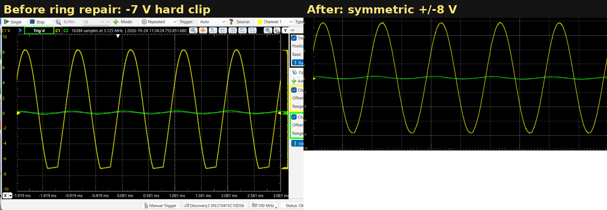
Figure 16 — Pedal output before and after the LED-ring repair, 2 V/div: a −7 V hard clip on one half, then symmetric ±8 V rounding.
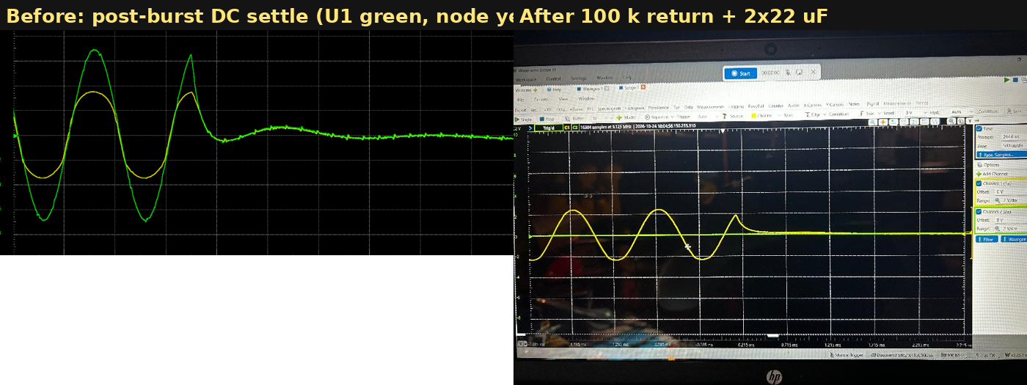
Figure 17 — End of a 500 ms burst at the drive output and ladder node, before and after the 100 kΩ node return and the 2 × 22 µF bass leg.
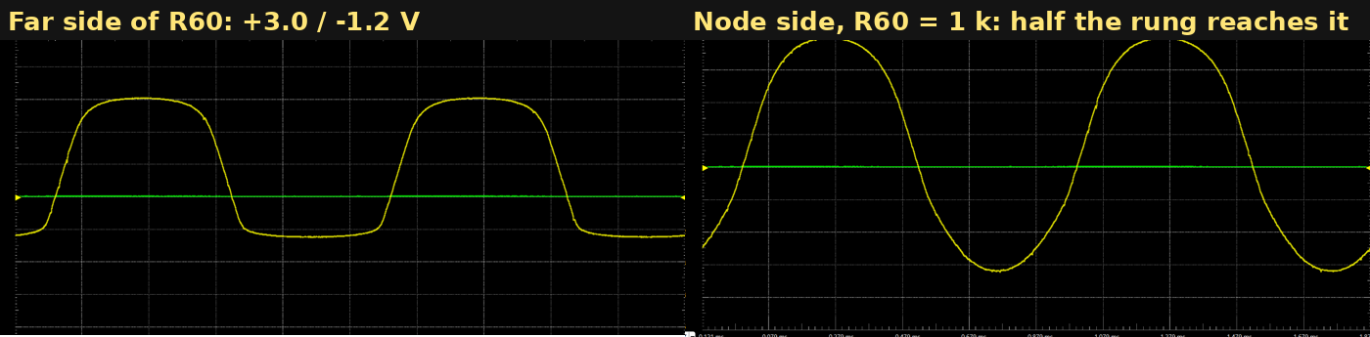
Figure 18 — First rung of the ladder on the far side of R60 (clamping +3.0 / −1.2 V) and on the node side with R60 at 1 kΩ, where only half of it reached the node; R60 is now 270 Ω.
*Figures 1–9 are analytical models derived from the exported netlist; Figures 10–18 are bench captures. Bench measurements supersede the models.*

