MALICE
Compressor / Gate Board
User's Guide, Rev 2 — setting the controls
Item | Value
Applies to | Compressor board, ±15 V version, as built and bench-verified 21–24 October 2026 (netlist Compressor.net 2026-10-02 plus the Rev 2 changes in §9)
What you need | A small flat screwdriver for the trimmers; a guitar or signal source; the pedal powered from its own supply. A scope on the test points is useful but not required.
Positions in this guide | Every trimmer position is given as a percentage of travel, clockwise from fully anticlockwise: 0 % = fully anticlockwise, 100 % = fully clockwise. The percentages already account for which trimmers run backwards (see §2), so set the number given and ignore the direction.
Companion | Technical Design Guide Rev 2 (same board) for the circuit detail, the response curves and the bench measurements behind these settings
Document date | 25 October 2026 (Rev 2; supersedes 3 October 2026)

1. What the board does
The compressor evens out the level of what comes out of the distortion stages so that chords and single notes land at a similar volume and the pedal feels consistent under the pick: quieter notes come up, louder ones come down. It is meant as a polish, not a sustainer. After it, a gate shuts the signal off between phrases so the noise that distortion brings up is not heard when you stop playing.
Thirteen trimmers on the board set all of this. They are meant to be set once, on the bench, to a preset; the player then has the pedal's main knobs. This guide explains what each trimmer does, which way it turns, how to tell what it is doing, and gives five compressor presets and two gate presets as starting points.

1.1 How to read the board
Compression is controlled by a voltage the board makes from the signal. You can see it two ways: the gain-reduction LED (brighter = more compression), and test point TP3, which reads 0 V with no compression and climbs about 33 mV for every decibel of gain reduction, so 0.33 V is 10 dB and 0.66 V is 20 dB. The gate has its own voltage at TP2: near 0 V when the gate is open, about +2.8 V when it is closed. If a setting doesn't seem to do anything, these two points tell you whether the board is doing what you asked.
Measured on the finished board (feedback mode, ERR1 at 50 %, full depth): a 1.4 V peak signal into the compressor gives 6 dB of gain reduction, 2.8 V gives 9 dB, 5.6 V gives 12.5 dB, 8.2 V gives 13.5 dB and 13 V (the drive at its rails) gives 16.5 dB. That is a steady 2:1 to 2.3:1 behaviour across the whole range of the pedal, and the numbers in §3 and §6 are built on it.
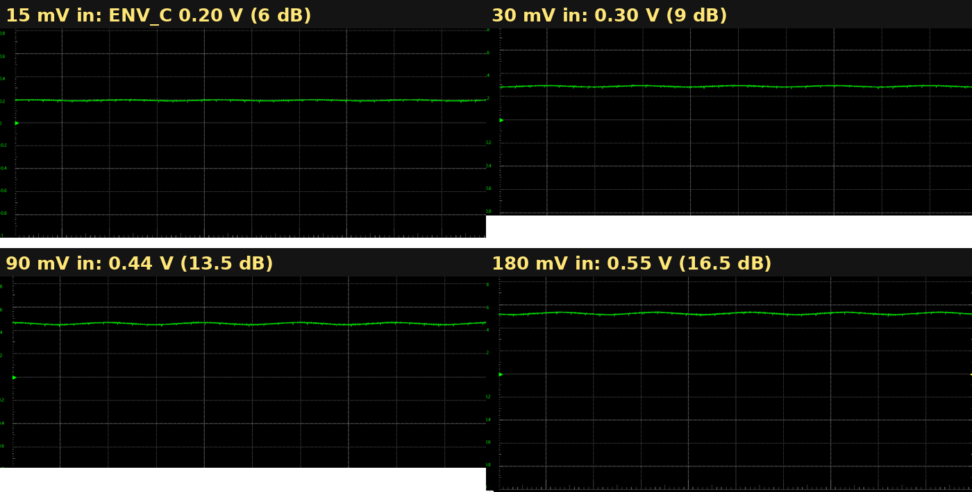
Figure 2 — TP3 (ENV_C) at four input levels, 1 kHz sine at the pedal input with the drive at full. The control voltage rises smoothly with level and never parks at its ceiling.

2. Which way the trimmers turn
Rev 1 of this guide said "every control: clockwise = more". On the board as built that is only true for six of the thirteen. The other seven run the opposite way: turning them clockwise reduces their effect. This was traced in the netlist (the pot ends that the wiper is tied to) and is consistent with how the board behaved on the bench. All the percentages in this guide are already corrected for it, so you can follow the numbers without thinking about direction; but if you adjust by ear, use this table.
Trimmer | Clockwise does | Fully anticlockwise (0 %) | Fully clockwise (100 %)
ERR1 | LESS compression (reversed) | maximum sidechain gain | no compression at all
C_LVL1 | LESS depth (reversed) | full depth (82 % of envelope) | no depth: VCA never moves
Knee1 | HARDER knee (reversed) | softest knee (5 kΩ) | hardest knee (0 Ω)
FST_ATT1 | FASTER attack (reversed) | slowest (about 30 ms) | fastest (about 5 ms)
SLW_ATT1 | FASTER attack (reversed) | slowest (about 360 ms) | fastest (about 35 ms)
FST_REL1 | longer release | shortest (about 27 ms) | longest (about 50 ms)
SLW_REL1 | longer release | shortest (about 190 ms) | longest (about 360 ms)
BLEND1 | more compressed (wet) | fully dry | fully compressed
G_LVL1 (gate threshold) | higher threshold | gate opens on almost anything | gate needs a strong signal
RV_THR1 (floor / mute) | higher floor | floor at its lowest | floor at its highest
G_FAST_ATT1 | FASTER opening (reversed) | slowest (about 48 ms) | fastest (about 1 ms)
G_SLOW_REL1 | FASTER closing (reversed) | slowest (about 520 ms) | fastest (about 47 ms)
Out_LVL1 | louder | −33 dB | +12.6 dB
Check it once on your board. With a signal playing, turn ERR1 fully clockwise: the gain-reduction LED must go dark and TP3 must drop to 0 V. If instead it gets brighter, your trimmers are fitted the other way round; mirror every percentage in this guide (use 100 minus the number). The two gate threshold pots are the least certain of the thirteen: confirm their sense by watching TP2 at each end.
The reversed seven will be corrected on the next board revision by swapping pins 1 and 3 on their footprints, after which the Rev 1 rule of thumb will be true again and this table will be retired.

3. The map and the starting point
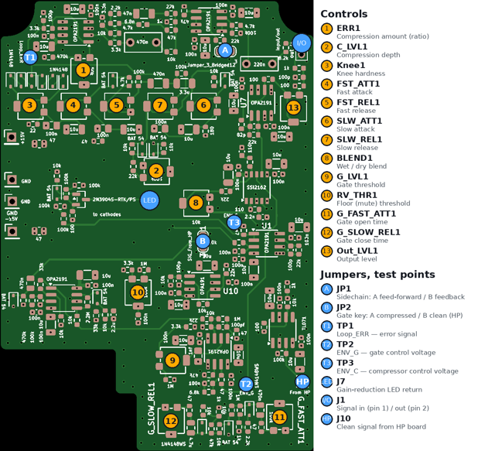
Figure 1 — Component side. Amber numbers are the trimmers, described in §4 in this order. Blue are the two solder jumpers, the three test points and the connectors.
Set everything here first, then adjust in the order given in §5 or go straight to a preset in §6. These are the positions the board was calibrated at.
# | Control | Set to | Why
13 | Out_LVL1 | 50 % | a little make-up gain; adjust last
1 | ERR1 | 50 % | moderate sidechain gain: the measured 2:1 behaviour
2 | C_LVL1 | 0 % | full depth (0 % is full on this board)
3 | Knee1 | 50 % | between hard and soft; refine by ear
4 | FST_ATT1 | 10 % | slow end: the pick attack comes through, then the compressor grabs
5 | FST_REL1 | 50 % | middle of its short range
6 | SLW_ATT1 | 10 % | rides the phrase, not the note
7 | SLW_REL1 | 50 % | holds through short gaps
8 | BLEND1 | 100 % | fully compressed for setting up; back off later for attack
9 | G_LVL1 | 0 % | gate wide open while you set the compressor
10 | RV_THR1 | 0 % | floor off while you set the compressor
11 | G_FAST_ATT1 | 90 % | fast opening (about 3 ms)
12 | G_SLOW_REL1 | 35 % | about 350 ms: holds through short gaps
A | JP1 | B (feedback) | see §7: the gentler, studio-style curve; this is how the board is now set
B | JP2 | B (clean signal) | gate keyed from the clean guitar signal via J10; this is how the board is now set

4. The controls, one by one

1. ERR1 — compression amount
What it does. Sets how strongly the board reacts to level. Internally it is the gain of the amplifier that measures the signal before it is turned into a control voltage. On this board it runs backwards: fully clockwise (100 %) there is no measurement and no compression; fully anticlockwise (0 %) the measurement is at its most sensitive. It is the closest thing on the board to a ratio control.
How to set it. Play a steady chord and turn ERR1 down from 100 % toward 0 % while watching the gain-reduction LED. It stays dark, begins to glow around 70 %, and is clearly working by 50 %. The useful region is from where it first glows to where it is fairly bright on your loudest playing; past that (below about 25 %) the board pulls hard on everything.
What you'll hear. High percentages: the pedal sounds untouched, with a little evenness added. Around 50 %: notes and chords land at a similar level, sustain feels longer; this is the measured 2:1 point. Low percentages: more squash and, in feed-forward mode (JP1 = A), a ducking effect where hitting harder makes the output quieter.
Range. 0 to about +17 dB of sidechain gain (at 0 %). With C_LVL1 at 0 % (full depth), compression is audible from about 70 % and strong by 30 %.
Interacts with C_LVL1. ERR1 decides at what level compression begins; C_LVL1 decides how deep it goes once it has begun. If you want compression to start earlier but stay gentle, lower ERR1 (more gain) and raise C_LVL1 (less depth).

2. C_LVL1 — compression depth
What it does. Scales the control voltage before it reaches the VCA. Reversed on this board: at 0 % the full envelope (82 % of it) is applied and the board can reach about 37 dB of gain reduction; at 100 % the detector can work as hard as it likes and the VCA never moves.
How to set it. With ERR1 where you left it, play and turn C_LVL1 from 100 % down toward 0 %. The LED and TP3 rise as you go. Set it so your hardest playing produces the amount of gain reduction you want: for a polish, the LED noticeably brightening on accents but never blazing, which is usually 20–40 %.
What you'll hear. Lowering the percentage deepens everything proportionally; the curve keeps the same shape and gets steeper. It does not change where compression starts.
Range. 0 to 82 % of the envelope; maximum gain reduction 0 to about 37 dB.

3. Knee1 — knee hardness
What it does. The board limits how large the measured error can get. Knee1 sets whether that limit is a hard stop or a gradual one. Reversed on this board: 100 % is the hard stop (0 Ω), 0 % the softest (5 kΩ). It shapes the top of the compression curve, how the board behaves on the loudest transients, not the onset.
How to set it. Hit hard single notes with ERR1 and C_LVL1 at working settings. At 100 % the loudest hits all land at exactly the same level with a slightly abrupt feel; at 0 % the loudest hits still get louder, just less. The bench measurement of TP1 shows the clamp reached at about ±2 V on a 90 mV input (Figure 3).
What you'll hear. Hard (high %): more consistent, more limited. Soft (low %): more dynamic on accents, more natural.
Range. 0 Ω (hard, 100 %) to 5 kΩ (soft, 0 %). Subtle unless you are driving the board hard.
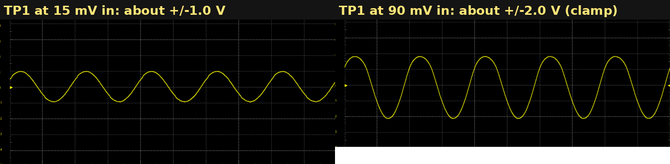
Figure 3 — TP1 (Loop_ERR) at 15 mV and 90 mV into the pedal. At the higher level the knee clamp is holding the error at about ±2 V.

4. FST_ATT1 — fast attack
What it does. How quickly the fast detector responds when a note arrives. The fast detector is what catches the pick attack. Reversed on this board: 100 % is fastest, 0 % slowest. Rev 2 changed the envelope smoother (§9), so the fastest attack is now about 5 ms rather than 2 ms; the slow end is unchanged.
How to set it. Play staccato single notes. Near 100 % the attack is clamped almost at once and pick clicks are softened. Turn toward 0 % until the pick retains its edge; around 10–30 % is usually the balance for a polish, 70–100 % for limiting.
What you'll hear. Fast (high %): smooth, slightly flattened attack. Slow (low %): the first few milliseconds of each note come through untouched, then the compressor grabs: more snap.
Range. about 5 ms (100 %) to about 30 ms (0 %).

5. FST_REL1 — fast release
What it does. How quickly the fast detector lets go after a note. Short releases follow each note individually; longer ones smooth between notes. This one turns the normal way: clockwise is longer.
How to set it. Play repeated eighth notes. At 0 % the gain recovers between every note and you may hear the level breathe. At 100 % it holds. The range on this board is deliberately short, so the effect is modest; leave it at 50 % or above unless you want an obvious pumping effect.
What you'll hear. Short: lively, each note pumps up slightly. Long: smoother.
Range. 27 ms (0 %) to 50 ms (100 %); the fixed circuit around it limits the top of the range.

6. SLW_ATT1 — slow attack
What it does. How quickly the slow detector responds. The slow detector rides the overall phrase and stops the fast one from pumping back up between notes. Reversed on this board: 100 % is fastest (about 35 ms), 0 % slowest (about 360 ms).
How to set it. Play a sustained chord and let it ring. Near 100 % the slow path joins the fast one almost immediately; near 0 % the compression settles in over a third of a second. Set it so a strummed chord sounds even across its first second.
What you'll hear. Fast (high %): the compressor arrives all at once. Slow (low %): a gentle settling in.
Range. 35 ms (100 %) to 360 ms (0 %).

7. SLW_REL1 — slow release
What it does. How long the slow detector holds after you stop playing. Turns the normal way: clockwise is longer.
How to set it. Play a phrase and stop. At 100 % the compression holds for about a third of a second after the last note before the gain recovers, which keeps noise from swelling up in short gaps. At 0 % it recovers in under 200 ms.
What you'll hear. Short: more dynamic, a hint of swell after notes. Long: more glued, quieter gaps.
Range. 190 ms (0 %) to 360 ms (100 %).
Two detectors, one result. The board always uses whichever of the fast and slow detectors is larger at the moment. Fast attack plus slow release is the standard polish setting: the fast path catches the hit, the slow path keeps it caught.

8. BLEND1 — wet / dry
What it does. Mixes the uncompressed signal back in with the compressed one before the gate. Normal direction: 0 % is dry (no compression heard at all); 100 % is entirely compressed.
How to set it. Set the compressor the way you want it, then back BLEND1 off from 100 % until a little of the natural attack and dynamics returns. Around 70–85 % keeps the polish while letting the pick through.
What you'll hear. This is parallel compression: the compressed signal supports the sustain and body, the dry signal supplies the transients. It makes heavy settings of ERR1 and C_LVL1 usable without sounding squashed.
Range. 0 % (dry) to 100 % (wet). The two signals are in phase, so any mix is clean.

9. G_LVL1 — gate threshold
What it does. The level below which the gate begins to close. This is the main gate control. Clockwise raises the threshold.
How to set it. Stop playing and let the pedal sit on its noise. Turn G_LVL1 toward 0 % until the gate opens on the noise (you hear it), then clockwise until it just closes, then a little further for margin. Play lightly: the gate should open on your quietest intentional note. If it doesn't, come back a touch.
What you'll hear. Too low: the gate never closes and noise is heard between phrases. Too high: soft notes and the tails of chords get cut off.
Range. About 0.31 to 0.78 V peak at the detector. With JP2 on B (as now set) the detector hears the clean guitar signal from the high-pass board, so the threshold follows the strings, not the distortion knob.
The gate has built-in hysteresis: it opens at a slightly higher level than it closes, so a note that is right at the threshold does not make it chatter.

10. RV_THR1 — floor (mute) threshold
What it does. A second, lower threshold. Below it the gate goes to its deepest setting (about −85 dB, effectively silent) rather than merely closing. Think of it as the mute level under the gate's working range. Clockwise raises it.
How to set it. Set it below G_LVL1. Start at 0 %, then raise it only enough that the pedal is silent when nothing is playing. It should never be above the gate threshold.
What you'll hear. Below the floor: silence. Between the floor and the gate threshold: the gate's normal, smoothly timed closing.
Range. About 0.31 to 0.63 V peak at the detector. Its action is smoothed over about 20 ms so it does not click.

11. G_FAST_ATT1 — gate open time
What it does. How quickly the gate opens once the signal crosses the threshold. Reversed on this board: 100 % is fastest (about 1 ms), 0 % slowest (about 48 ms).
How to set it. Play sharp, percussive notes from silence. At 100 % the gate opens before you can hear it move. Turn toward 0 % only if the opening sounds clicky on bass notes; below about 80 % (around 10 ms) the start of each note begins to be audibly rounded off.
What you'll hear. Fast (high %): transparent. Slow (low %): a soft fade-in on each note from silence.
Range. 1 ms (100 %) to 48 ms (0 %).

12. G_SLOW_REL1 — gate close time
What it does. How long the gate takes to close after the signal drops below the threshold. Reversed on this board: 100 % is fastest (about 47 ms), 0 % slowest (about 520 ms).
How to set it. Play a phrase with a short rest in it. Near 100 % the gate snaps shut in the rest: tight, but tails are cut. Near 0 % it fades out over half a second. Set it so the natural decay of a chord is not chopped but the gap before the next phrase is quiet; 30–40 % (about 300–350 ms) is a good middle.
What you'll hear. Short (high %): tight, choppy. Long (low %): natural decay, noise lingers a moment.
Range. 47 ms (100 %) to 520 ms (0 %).

13. Out_LVL1 — output level
What it does. The gain of the final stage, after the gate. Normal direction: clockwise is louder.
How to set it. Set it last. With the pedal in bypass and then engaged, match the two volumes by ear or with a meter at the output. Unity is around 35 %; compression usually wants a little make-up gain, 45–60 %.
What you'll hear. Below 35 %: quieter than the input. Above: up to +12.6 dB of make-up gain.
Range. −33 dB (0 %) to +12.6 dB (100 %).

5. Setting it up, in order
- Jumpers first (§7). For a studio-style polish JP1 on B (feedback). JP2 on B (clean key) if the J10 wire from the main board is fitted, otherwise A.
- All trimmers to the §3 starting point. Out_LVL1 to 50 %.
- Gate wide open: G_LVL1 and RV_THR1 at 0 %, so the compressor can be heard on its own.
- Compressor onset: ERR1 down from 100 % until the LED glows on normal playing (about 60–70 %).
- Compressor depth: C_LVL1 down from 100 % until accents bring the LED up clearly but it never pins (about 20–40 %).
- Attack: FST_ATT1 for the pick (10–30 % for a polish), SLW_ATT1 for the phrase (10–20 %). Then releases, both at 50 % or above to start.
- Knee: by ear on hard hits. Blend: back off from 100 % until the attack returns.
- Gate: raise G_LVL1 until the noise closes it; check your quietest note opens it. Then RV_THR1 just high enough for silence at rest, below G_LVL1.
- Gate timing: G_FAST_ATT1 as fast (high %) as is click-free; G_SLOW_REL1 so chord tails aren't chopped.
- Output level: match bypass and engaged.
- Play for ten minutes and revisit ERR1 and G_LVL1; they are the two that drift in your ear.

6. Presets
Five compressor presets and two gate presets, in the spirit of the switchable compressor on a studio preamp: pick the character, then fine-tune with ERR1 for amount and Out_LVL1 for level. All positions are percent of travel clockwise, already corrected for the reversed trimmers. The Glue preset is the one the board was measured at (Figure 2); the others are derived from it and from the Rev 1 model, and are starting points for the ear, not final values.
Control | A: Polish (light, transparent) | B: Glue (measured 2:1) | C: Squeeze (aggressive) | D: Limiter (catch peaks) | E: Parallel (New York)
JP1 | B feedback | B feedback | B feedback | B feedback | B feedback
ERR1 | 65 % | 50 % | 20 % | 35 % | 40 %
C_LVL1 | 30 % | 0 % | 0 % | 0 % | 0 %
Knee1 | 25 % | 50 % | 80 % | 100 % | 50 %
FST_ATT1 | 10 % | 10 % | 80 % | 100 % | 30 %
FST_REL1 | 80 % | 50 % | 20 % | 100 % | 50 %
SLW_ATT1 | 20 % | 10 % | 50 % | 100 % | 20 %
SLW_REL1 | 70 % | 50 % | 30 % | 100 % | 50 %
BLEND1 | 80 % | 100 % | 100 % | 100 % | 50 %
Out_LVL1 | 45 % | 50 % | 60 % | 55 % | 50 %
Gain reduction on hard strum | about 4–6 dB | 10–16 dB | 20 dB+ | peaks only | 10–16 dB on the wet half
Feel | barely there; evens chords | longer sustain, consistent level | obvious squash, pumping on release | flat ceiling, dynamics below it untouched | sustain with the pick left alone
How the presets relate: A to C is the same shape with more sidechain gain, a harder knee and faster timing at each step. D turns the board into a peak limiter by making both detectors fast and the knee hard, so only the loudest transients are touched. E is B with the dry signal mixed back in, the classic parallel trick.
Gate control | Natural (chords, clean tails) | Tight (riffs, high gain)
JP2 | B (clean key via J10) | B (clean key via J10)
G_LVL1 | set by ear: just above the noise | a little above that; opens on the pick
RV_THR1 | 0–10 % | 10–20 %
G_FAST_ATT1 | 85 % (about 4 ms) | 100 % (about 1 ms)
G_SLOW_REL1 | 30 % (about 350 ms) | 75 % (about 120 ms)

7. The two solder jumpers
Both jumpers are three-pad solder jumpers with a thin copper bar joining pads 1 and 2 as the factory default. To select the other position you must cut that bar first (scrape through it with a knife and confirm with a meter that pads 1 and 2 read open), then bridge pads 2 and 3 with solder. Bridging 2–3 without cutting the bar joins all three pads, and on both of these jumpers that shorts two op-amp outputs together. That exact mistake was the cause of the October 2026 fault (§9); it draws 0.45 A at the 9 V jack, heats the VCA and halves the output waveform.
JP1 — where the compressor listens. Position A (pads 1–2, the factory bar) takes the signal before the compressor: feed-forward. Position B (pads 2–3) takes the signal after it: feedback. In A the board can over-react: above a certain level, hitting harder makes the output quieter, which is dramatic and can be useful as an effect, but is not what a glue compressor does. In B the compressor regulates its own output, the curve is a gentle soft knee, and the controls behave the way players expect. The board is now set to B, bar cut.
JP2 — what the gate listens to. Position A (pads 1–2, the factory bar) keys the gate from the compressed signal. Position B (pads 2–3) keys it from the clean guitar signal supplied by the high-pass board on J10, amplified ×11 on this board, which makes the gate ignore the distortion stages entirely and respond only to the strings. The board is now set to B, bar cut; this needs the J10 wire from the main board's TO_COMP tap, without which the gate never opens.
After any jumper change, two meter checks with the power off: U5 pin 1 to U1 pin 7 should read about 10 kΩ (the BLEND pot), and U8 pin 6 to U1 pin 7 should read open.

8. If something's wrong
Symptom | Check | Likely cause
No compression, LED never lights | TP3 stays at 0 V while playing | ERR1 or C_LVL1 at 100 % (both are reversed: 100 % is off); JP1 not bridged
LED on with no signal | TP3 above 0 V at rest | Noise upstream is above the onset; raise the gate first, then raise ERR1 (less gain)
Pumping / breathing | LED pulsing with the rhythm | Releases too short, or ERR1 too low (too much gain); check JP1 = B
Hitting harder gets quieter | — | Feed-forward over-compression (JP1 = A with ERR1 low); raise ERR1 or move to B
Gate chatters on sustained notes | TP2 flicking between 0 and +2.8 V | G_LVL1 set right at the sustain level; lower it slightly or lengthen G_SLOW_REL1 (lower %)
Gate never closes | TP2 stays near 0 V at rest | G_LVL1 too low, or noise upstream above threshold
Gate never opens | TP2 stays at +2.8 V while playing | G_LVL1 or RV_THR1 too high; JP2 on B with nothing on J10
Notes start with a click | — | G_FAST_ATT1 at 100 % on a bass-heavy signal; back it off a little
Chord tails chopped | — | G_SLOW_REL1 too high (too fast), or G_LVL1 too high
Output distorted at high settings | — | Out_LVL1 too high for the stages after it; check it is not above unity when not needed
Pedal draws 0.4 A or more; VCA or input op amp warm; output half-wave rectified | Ohms U5 pin 1 to U1 pin 7: near 0 Ω instead of 10 kΩ | A solder jumper bridged across all three pads (§7). Clear it; nothing else on the board will fix it
Compressor is silent | TP2 at +2.8 V | JP2 on B without the J10 wire; move JP2 to A or fit the wire

9. What changed in Rev 2 (October 2026)
The board described by Rev 1 of this guide was bench-tested in October 2026 against the Distortion Studio's drive stage and the following was found and fixed. The Technical Design Guide Rev 2 has the measurements.
- Fault found and cleared. Both solder jumpers had been bridged 2–3 without the factory 1–2 bar being cut, so JP1 shorted the input buffer's output to the compressor's output and JP2 shorted the gate-key amplifier's output to it as well. With signal present the four outputs fought each other: 60 mA per rail into the board, rails sagging to ±9 V, the VCA and input buffer hot, and a half-wave output. Clearing the bridges restored the pedal to 0.148 A and a clean output.
- Trimmer directions documented (§2). Seven of the thirteen trimmers run backwards on this build. All positions in this guide are given in corrected percentages.
- Envelope smoother changed. C41 was 100 nF; it was briefly 1 µF (to cure a 1 kHz ripple on ENV_C that made the gain wobble within each cycle), and is now 100 nF again with a 220 nF added from C_LVL1 pin 1 to ground: a two-pole smoother with the same ripple rejection and a fifth of the lag. Fastest compressor attack is now about 5 ms instead of 2 ms.
- Jumpers set to feedback (JP1 = B) and clean gate key (JP2 = B).
- Parts replaced during fault-finding: U5 (OPA2191), U9 (SSI2162), U10 (OPA191). None was the cause; U5 and U9 had run hot for hours and were renewed.
- Measured behaviour (Figure 2): 2:1 to 2.3:1 across the pedal's whole range at ERR1 50 %, full depth, feedback mode; knee clamp at TP1 about ±2 V.
- Open item: a 1 kHz square wave at full drive shows the compressor output leaning 25–30 % within each half-cycle; the cause (compressor or gate control voltage) is still being measured. It does not show on guitar at the Glue preset.

10. Reference
# | Control | Value | Function | Range | Clockwise
1 | ERR1 | 50 k | Compression amount | 0 to +16.6 dB sidechain gain | LESS (reversed)
2 | C_LVL1 | 100 k | Compression depth | 0 to about 37 dB max gain reduction | LESS (reversed)
3 | Knee1 | 5 k | Knee hardness | soft → hard | HARDER (reversed)
4 | FST_ATT1 | 50 k | Fast attack | about 30 ms → 5 ms | FASTER (reversed)
5 | FST_REL1 | 470 k | Fast release | 27 – 50 ms | longer
6 | SLW_ATT1 | 100 k | Slow attack | 360 ms → 35 ms | FASTER (reversed)
7 | SLW_REL1 | 500 k | Slow release | 190 – 360 ms | longer
8 | BLEND1 | 10 k | Wet / dry | dry → wet | wetter
9 | G_LVL1 | 100 k | Gate threshold | 0.31 – 0.78 V pk at detector | higher
10 | RV_THR1 | 100 k | Floor threshold | 0.31 – 0.63 V pk at detector | higher
11 | G_FAST_ATT1 | 100 k | Gate open | 48 ms → 1 ms | FASTER (reversed)
12 | G_SLOW_REL1 | 100 k | Gate close | 520 ms → 47 ms | FASTER (reversed)
13 | Out_LVL1 | 20 k | Output level | −33 to +12.6 dB | louder
Test points: TP3 (ENV_C) 0 V = no compression, 33 mV per dB of gain reduction (0.33 V = 10 dB, 0.66 V = 20 dB). TP2 (ENV_G) about 0 V open, about +2.8 V closed. TP1 (Loop_ERR) is the raw error signal; it should swing no further than about ±2 V on peaks.
*Ranges are calculated from the component values and confirmed where stated by the October 2026 bench measurements; your board will land within a few percent of them.*

