MALICE
The Drive of Malice
Technical Reference, Revision C — as built, 25 October 2026
Item | Value
Board | Malice Madrigal main board (RAT_Board2.net as built), 60.0 × 106.4 mm
Supply | ±15 V from the Reactor via bused headers, each rail through 47 Ω with local decoupling; 9 V barrel input with reverse-polarity protection, a cut-off near 14 V and a surge suppressor
Drive op amp | U1, socketed single DIP-8, OPA1641 fitted
Document date | 25 October 2026, Revision C (supersedes Revision B of 6 October 2026, which is the version on the website, and Revision A)
Status | As built and bench-measured 21–25 October 2026. The clipping section is still being tuned by ear; values marked "current" may move again

1. What this section does
This is the heart of the pedal: the stage that turns a clean signal into a distorted one, and the two additional clipping circuits that sit alongside it. Three tiers live here, each reachable from the panel: a high-gain amplifier that clips softly into a ring of red LEDs (always in circuit), a zener ladder that clamps hard (the Clean switch), and a two-transistor fuzz (the CRz switch). They can be used alone or stacked, and they are arranged so that each one takes a portion of the waveform the one before it left.
The pedal's full-frequency philosophy still holds: the amplifier applies the same gain to a five-string bass's low B as to a guitar's top string, and the decision about what to keep is left to the Wall of Ice, the Twin Assassins, the Aurora Curtain and the player. What changed in Revision C is the shape of the lift above the bass, after bench work showed the previous three-leg voicing was boosting the top octave straight into the clippers.

2. The drive amplifier
U1 is a non-inverting stage with the Distortion control (50 kΩ audio taper) as its feedback resistor, R54 (33 kΩ) across the pot to cap the maximum, and C7 (330 pF) across it to cap the bandwidth. From the inverting input, two resistor-and-capacitor legs run to ground in parallel. Each leg sets how much gain the stage has above its own corner:
Leg | Values (as built) | Takes effect above | What it does
Full-band | R5 390 Ω + C3, C11 2 × 22 µF (44 µF) | 9.3 Hz | the whole signal, equally, from below the lowest bass note
Presence | R4 390 Ω + C25 220 nF | 1.9 kHz | about +5 dB from 3 to 7 kHz: pick attack and note definition
Loop cap | C7 330 pF across the Dist pot | turns the lift back down above about 24 kHz at full Dist (17 kHz with 470 pF, 12 kHz with 680 pF) | keeps the lift a band, not a shelf, so the harmonics the clippers make are not amplified
At full Dist the gain is 34 dB at 100 Hz, 36.5 dB at 1 kHz, 39.7 dB at 5 kHz and 39.5 dB at 10 kHz: a flat bass plateau and a +5 dB presence band rather than the +10 dB shelf of Revision B. The band is the reason Revision C sounds clearer: in Revision B the three legs stayed in parallel to the top of the audio range, and the tilt survived clipping, so the LED ring's harmonics came out with 9 dB of extra top end, heard as glassy fizz that the Aurora then had to remove. With two legs and a loop cap the gain above the ring's knee is nearly flat (12 dB at 100 Hz, 16.5 dB at 10 kHz) and the clipped signal keeps the balance the note went in with.
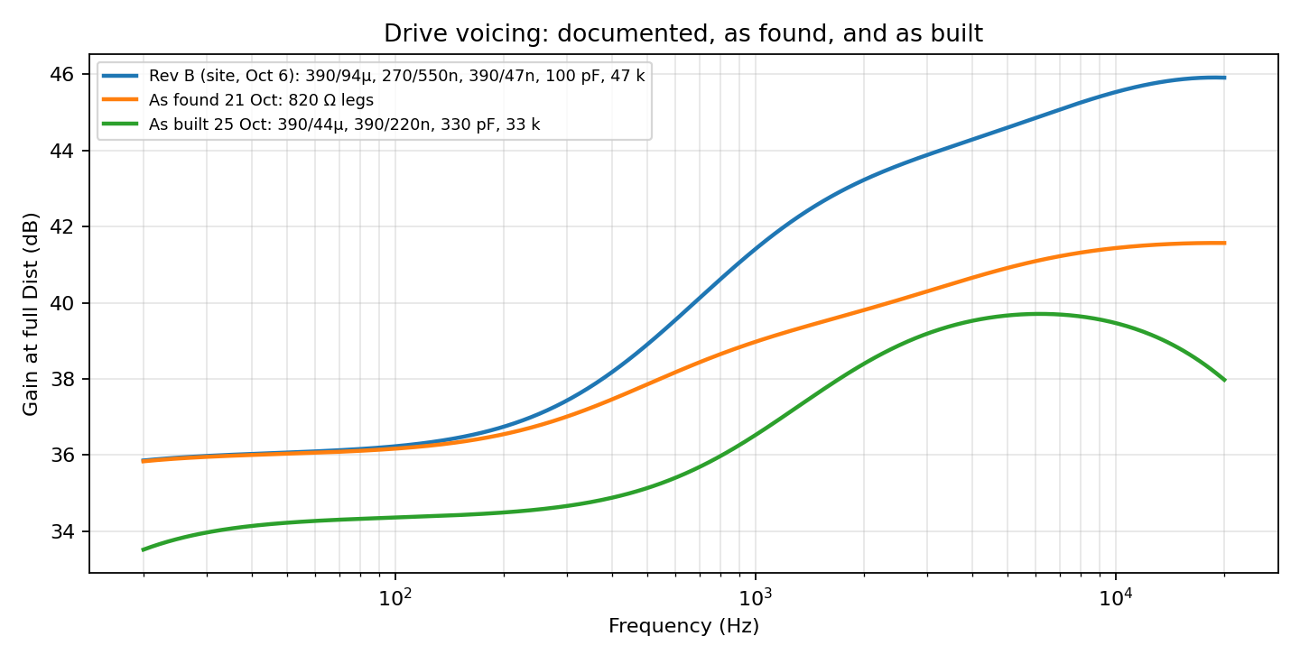
Figure 1 — Drive gain at full Dist: the Revision B voicing on the website, the board as found on 21 October (two 820 Ω legs that had been fitted undocumented), and the Revision C as-built voicing.
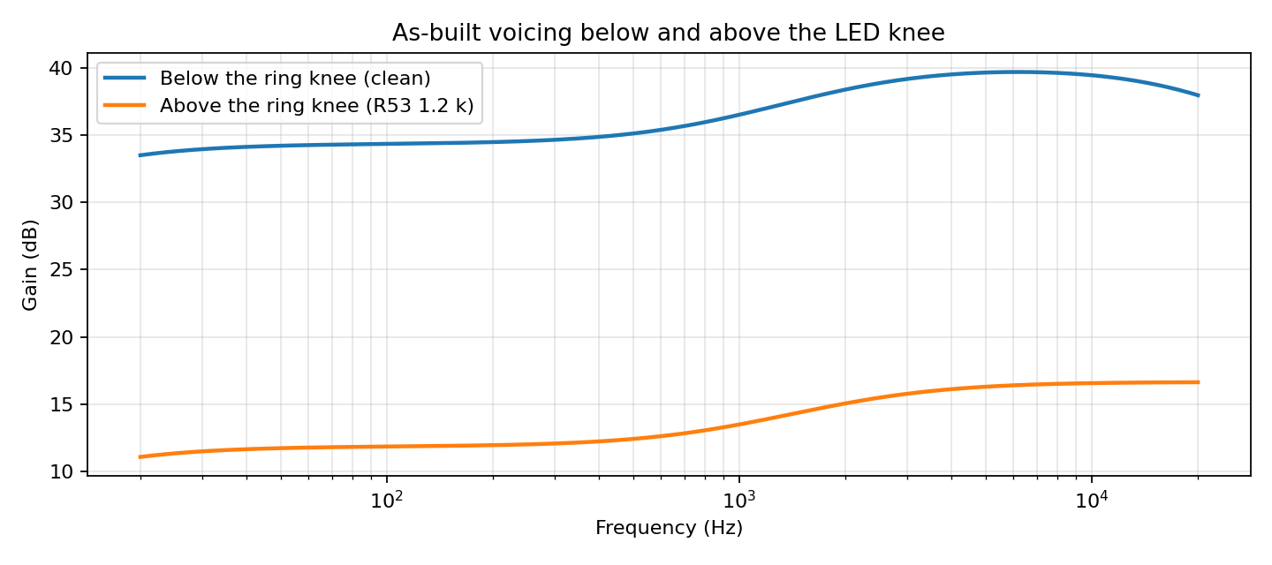
Figure 2 — The as-built voicing below and above the LED ring's knee. The 4 dB of tilt that survives clipping is what the harmonics receive.
Because both legs share the same feedback resistor, turning Distortion scales them together; the voicing does not change with the setting. The LED knee is reached at about 100 mV of input at full Dist (39 dB chain gain from the jack with the filters open), about 250 mV with Dist at a third, and ordinary guitar levels never reach it below about a quarter of the knob. A hot source, a synth or a line-level feed, lives in the bottom third.
Bass leg capacitors. Revision B used 2 × 47 µF (4.3 Hz). Revision C uses 2 × 22 µF (9.3 Hz): the low B of a five-string is within 0.3 dB, and the leg recovers from the DC that asymmetric clipping leaves on it in 17 ms instead of 37, which tightens staccato playing. Part of the same change was a 100 kΩ DC return on the zener ladder node (§4).

3. Tier 1: the LED ring
Twelve red LEDs, six per polarity, sit in two anti-parallel strings across U1's feedback path and share a series resistor R53, now 1.2 kΩ. The knee lands around 9.5 V of output (six reds at the few hundred microamps the ring passes near the knee), and the stage bends gradually: once the ring conducts, the feedback resistance drops from up to 20 kΩ to about 1.1 kΩ, so the gain above the knee falls to about 15 dB at 1 kHz rather than to zero, and the output keeps climbing slowly until the op amp's own swing stops it near ±13.5 V.
R53 was 3.3 kΩ in Revision B. That left 22 dB of gain above the knee, enough that a 500 mV pick at full Dist reached 15 V and flat-topped on the op amp's rails, a hard clip on top of the soft one. At 1.2 kΩ the ring stays in charge up to about 850 mV of input at full Dist, which covers single coils and most humbuckers on a hard strum; 1 kΩ would clear 1 V and 820 Ω any passive pickup, at the cost of a firmer knee. Below the knee R53 does nothing, so the clean range is unchanged.
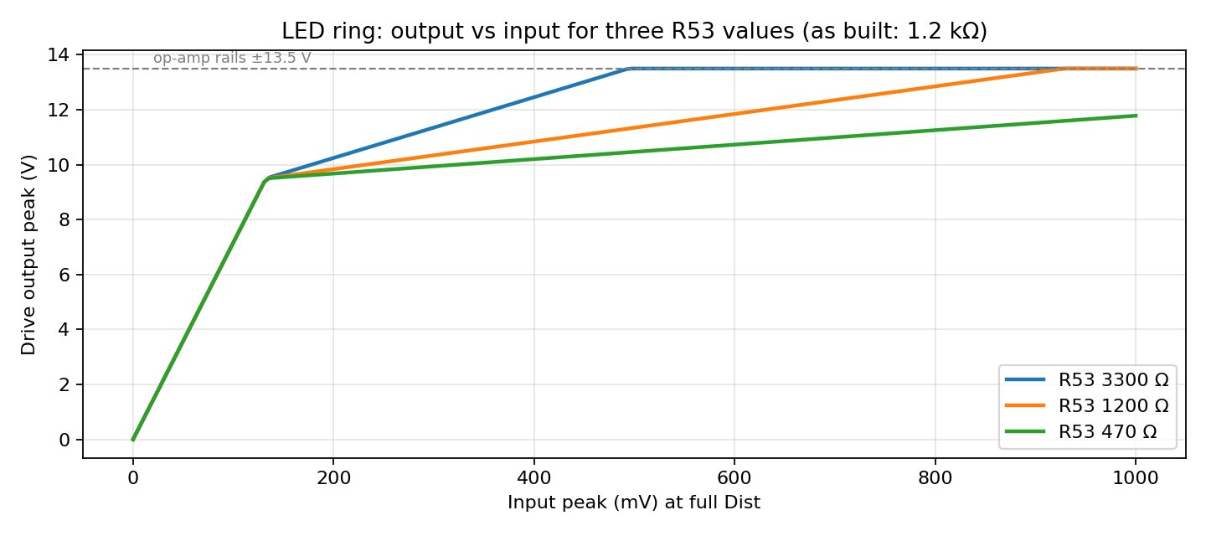
Figure 3 — Drive output against input at full Dist for three values of R53. Where a curve meets the rail line, the hottest peaks start to flat-top.
Symmetric by construction. Both halves of the wave see six identical LEDs, so both begin to round at the same voltage and in the same way, producing odd-order, amplifier-like harmonics. This only holds if all twelve conduct. On 24 October one string was found with a copper bypass from D19's cathode to ground that turned it into a four-LED hard clamp at 7 V, and the output was lopsided (Figure 4); the symptom that found it was four LEDs lighting brightly and two staying dark, which in a series string can only mean the current is leaving the string before the dark pair. Clearing the bypass and refitting D18 and D6 restored symmetry.
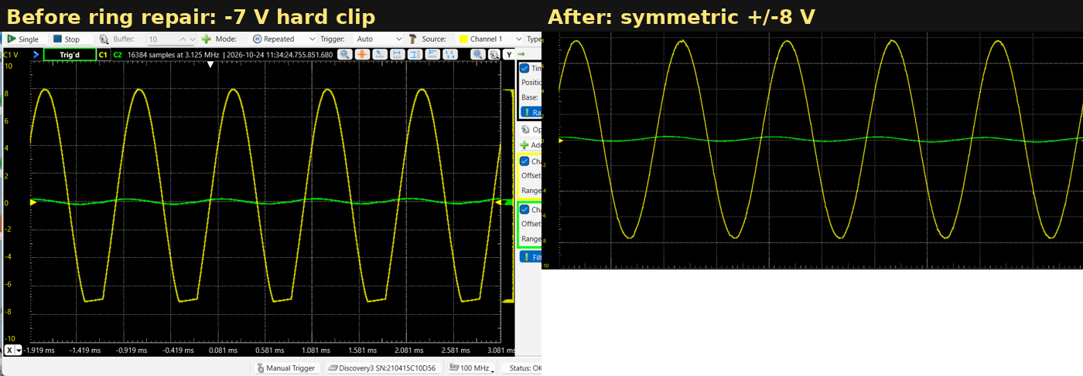
Figure 4 — Pedal output before and after the ring repair, 2 V/div: a hard −7 V clip on one half, then symmetric ±8 V rounding.
Modding notes. All twelve LEDs must be the same type, or the two halves clip at different levels. Changing colour moves the knee: six higher-voltage LEDs (green, blue, white) would put it beyond the op amp's swing and the ring would stop clipping. R53 sets how firm the knee is and how hot a pickup can be before the rails take over: smaller is firmer. The old MV50640 red LEDs used here have the long leg on the large internal plate, the reverse of the usual convention; check polarity with a meter, not by eye.

4. Tier 2: the zener ladder
The hard clipper is a two-rung ladder on the node after U1: U1's output passes through R34 (330 Ω), C10 (1 µF) and R64 (470 Ω) to the clipper node, which feeds U3A, a unity buffer, through C30 (220 nF). Revision C adds R62, 100 kΩ from the node to ground: the node previously had no DC path while the diodes were off and drifted on C10 and C30 after loud passages (Figure 7); it now settles in a few tens of milliseconds.
Rung | Node-positive half | Node-negative half | Connects
1, the bend | D10 2.7 V zener + D9 1N914: about +3.2 V, soft (low-voltage zeners have a gradual knee) | D2, D1 two 1N914: about −1.2 V, sharp | through R60, 270 Ω (Revision B: 1 kΩ as found, 330 Ω intended)
2, the ceiling | D21 3.9 V zener + D27 1N914: +4.6 V | D29 3.9 V zener + D28 1N914: −4.6 V | directly at the node
The first rung is asymmetric on purpose. Behind R60 it bends the node rather than clamping it: the node sits at the rung's knee plus R60 / (800 Ω + R60) of whatever the drive puts out beyond it, about a quarter with 270 Ω. The sharp 1.2 V side arrives first and the soft 3.2 V side later, so through the middle of the Dist range (3 to 8 V of drive output) the two halves of the wave are a volt or more apart and the tone carries even-order character. Above that the second rung catches both halves at ±4.6 V and the top of the Dist range goes symmetric again: the asymmetry tapers off as the drive gets harder. R60 is the control for that taper: 100 Ω keeps the halves apart to the top (tried and rejected as thin and spitty at high drive), 330 Ω makes them meet at about 8 V of drive, 270 Ω at about 10 V.
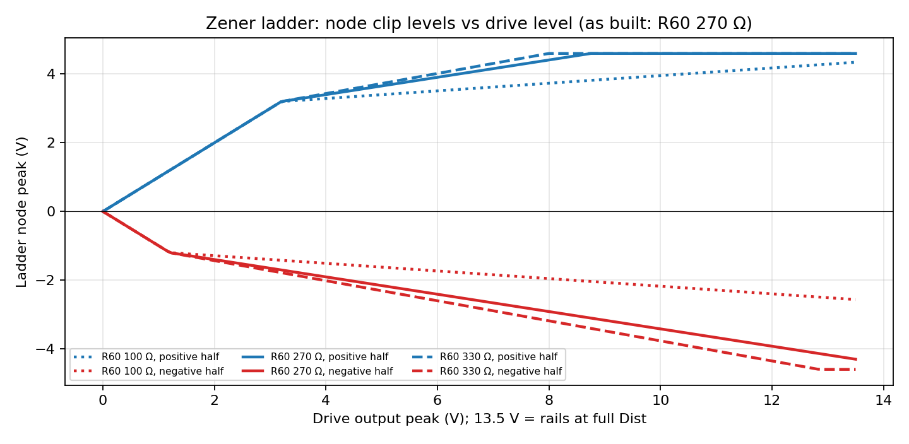
Figure 5 — Clip levels at the ladder node against drive level for three values of R60. The gap between a pair of lines is the asymmetry; a line going flat at ±4.6 V is the second rung taking over.
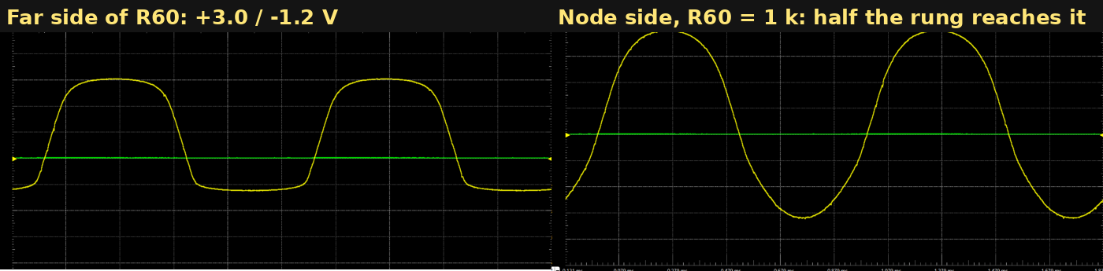
Figure 6 — The first rung measured on the far side of R60 (clamping +3.0 / −1.2 V, 1 V/div) and on the node side with R60 at 1 kΩ, where only half of it reached the node. With 270 Ω about three-quarters does.
Which way round. The Aurora Curtain's filter stages invert, so the node's negative half appears as the top of the wave at the output jack. The sharp 1N914 side was placed on the node-negative half so that the hard, early bend lands on the same polarity the CRz fuzz clips first (the top), and the two asymmetries add rather than cancel. If the fuzz's polarity is ever changed, swap the two branches of the first rung.
Level and the compressor. The ±4.6 V ceiling is a third of the ring's, so switching the ladder in costs about 9 dB; that is a deliberate trade for travel on the Volume knob in hard-clip mode. The compressor sits after the ladder, so in hard-clip mode it never sees more than ±4.6 V and runs about 5 dB less gain reduction than in the soft mode, which narrows the level step to roughly 4 dB with the compressor in. Revision B's rungs were 6.8 V and 9.1 V (±7.4 / ±9.7 V); they were lowered for aggression and knob range before the ring fault was found, and left there after it because the ring and ladder now sound distinct with the ring soft again.
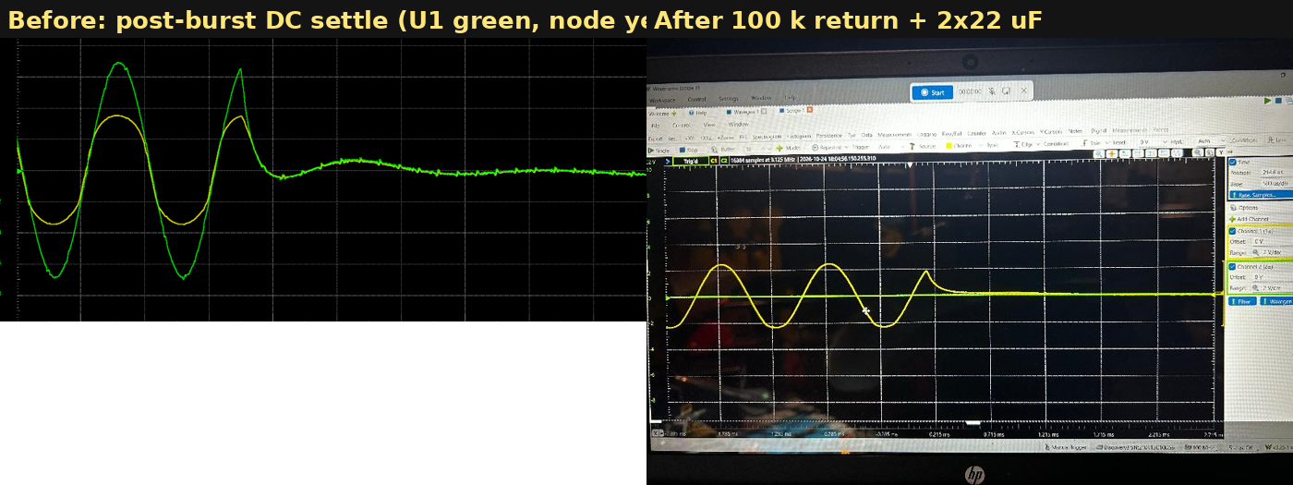
Figure 7 — End of a 500 ms tone burst at U1's output and the ladder node, before and after the 100 kΩ node return and the 2 × 22 µF bass leg. The slow sag-and-overshoot is DC left by asymmetric clipping; it is gone within half a cycle after the change.

5. Tier 3: the CRz fuzz
Unchanged in Revision C. A two-transistor fuzz (MMBT3904 and MMBT5088) on its own section of the board with its own ground island and supply filtering, driven from the ladder node through its own level control, with Asymmetry, Fuzz Gain and Fuzz Level trimmers behind the panel. It clips the top of the wave first, peaks near ±4.4 V, and carries a built-in bass cut between its stages (−3 dB near 100 Hz) that keeps it articulate; it therefore wants more low end coming in than the other two tiers.

6. Coupling and output
Coupling corners are 1.6 Hz at the input and about 7 Hz between stages; nothing in the band is rolled off between stages. After the clipping tiers the signal goes to the Aurora Curtain and returns, optionally through the compressor, to the Volume control and a buffered output. The buffers are halves of an OPA2191 referenced to ground on the ±15 V rails; there is no mid-rail bias anywhere on the board.

7. Specifications (as built, 25 October 2026)
Item | Value
Supply | ±15 V from the Reactor; 9 V barrel input with reverse-polarity protection, cut-off near 14 V, surge suppressor
Drive gain | 0 to about 40 dB. At full Dist: 34 dB at 100 Hz, 36.5 dB at 1 kHz, 39.7 dB at 5 kHz, 39.5 dB at 10 kHz (R54 33 kΩ, C7 330 pF)
Voicing legs | 390 Ω / 44 µF (9.3 Hz); 390 Ω / 220 nF (1.9 kHz); 330 pF loop cap
Tier 1, LED ring | Twelve red LEDs, six per polarity, R53 1.2 kΩ. Knee near ±9.5 V, about 15 dB of residual gain, ceiling near ±13.5 V; rails reached at about 850 mV input at full Dist. Always in circuit
Tier 2, zener ladder | First rung +3.2 V (2.7 V zener + 1N914) / −1.2 V (two 1N914) through 270 Ω; second rung ±4.6 V (3.9 V zeners + 1N914) at the node; 100 kΩ node return. Clean switch
Tier 3, CRz fuzz | MMBT3904 and MMBT5088 with Asymmetry, Fuzz Gain and Fuzz Level trimmers. Peaks near ±4.4 V; −3 dB at 100 Hz and 45 kHz. CRz switch
Op amp | U1, socketed single DIP-8, OPA1641 fitted
Coupling | 1.6 Hz at the input, about 7 Hz between stages
Controls | Dist (50 kΩ audio taper), Volume (10 kΩ), Notch Blend (dual); Comp, Clean and CRz switches
Board | 60.0 × 106.4 mm

8. Service checks
- U1 pin 7 at about +14.7 V and pin 4 at about −14.85 V (the 47 Ω drops); whole pedal 0.148 A at 9 V with the compressor in, steady, unaffected by touching the boards.
- U1 pin 6, U3 pin 1 and U3 pin 7 at 0 V within a few millivolts with no signal.
- Dist fully up, 15 mV at 1 kHz into the pedal: about ±1.4 V at the compressor input (39 dB chain gain); 90 mV gives ±8.2 V; the ring is just rounding.
- With a sine running, all twelve ring LEDs glow on their half-cycles and both halves of U1's output round at the same level (Figure 4, right). Four bright and two dark in a string is a bypass, not a bad LED.
- Ladder in (Clean switch), 60 mV at full Dist: the node at about +3.5 / −2.3 V; 90 mV: about +4.6 / −3.5 V, the positive half flat on the second rung.
- Ladder out: the node follows U1 up to about ±13.5 V.
- CRz in, all three trimmers fully up, heavy drive: the low-pass send near +4.2 / −4.4 V.
- Raise the DC input slowly: the protected 9 V drops out near 14 V and returns below it. Reverse the DC input: nothing powers up and nothing gets warm.

9. Change log
Reference | Revision B (6 Oct, website) | As found 21 Oct | Revision C (25 Oct) | Why
R3 / C23 (treble leg) | 390 Ω / 47 nF | 820 Ω / 47 nF, later 120 nF | removed | three legs made a shelf to 20 kHz; the lift is now a band
R4 / C24 + C25 (mid leg) | 270 Ω / 220 + 330 nF | 820 Ω / 330 nF | 390 Ω / 220 nF | presence corner 1.9 kHz; 220 nF preferred by ear over 330 nF
C3, C11 (bass leg) | 2 × 47 µF | 2 × 47 µF | 2 × 22 µF | faster DC recovery, bass unchanged to 31 Hz
R54 | 47 kΩ | removed | 33 kΩ | maximum gain; found at 33 k, kept
C7 | 100 pF | 47 pF | 330 pF | loop ceiling; 470–680 pF if the top octave gets sharp
R53 | 3.3 kΩ | 470 Ω | 1.2 kΩ | ring stays in charge up to ~850 mV input; 3.3 k let hot picks hit the rails, 470 Ω was a hard ring
LED ring | twelve reds | copper bypass around D18/D6 | bypass cleared, D18/D6 refitted | symmetry restored
Ladder rung 1 | 6.8 V + 1N914 both halves, 1 kΩ | 2.7 V zener + 1N914 / MV50640 LED + 1N914, R60 1 kΩ | 2.7 V zener + 1N914 / two 1N914, R60 270 Ω | deliberate asymmetric band, tapering off at full Dist; 100 Ω tried and rejected
Ladder rung 2 | 9.1 V + 1N914 (±9.7 V) | 3.9 V + 1N914 (±4.6 V) | unchanged ±4.6 V | aggression and Volume-knob range
Ladder node return | none (22 kΩ to ground after C10 in Rev B text) | none | R62 100 kΩ node to ground | stops DC drift after loud passages
Revision A (single-supply, 7.5 V reference, three LEDs per side with 100 Ω) is obsolete and is kept only in the archive.

10. Open items and next spin
- Listening test of C7 at 470 pF versus 330 pF with the final presence leg; the 330 pF leaves the lift at +4.5 dB at 15 kHz.
- The asymmetric first rung is still being tuned by ear (R60 between 220 and 330 Ω; D10 value 2.7 to 3.3 V). Values here are current, not final.
- If the second rung is ever raised (4.7 V zeners, ±5.4 V), R60 must rise with it (about 470 Ω) to keep the taper at full Dist.
- Next spin: route the ladder node return on the board; make R60 and R53 easy to change (sockets or pads); DPDT for the Comp switch so the compression indicator only lights with the compressor in; optional second pole on the Clean switch to switch R54 in only in soft mode.

11. For the player (website notes)
What the player hears after Revision C, for the player's guide and front page:
- The Dist knob: clean boost for the first quarter, the LED ring rounding the sound from about a quarter up with a normal guitar, fully into the ring by two-thirds. Hot pickups, synths and line-level sources reach the ring in the bottom third; start low.
- The drive is full-range: a bass or a synth keeps its bottom. Tightening is the Wall of Ice's job, mud control the Twin Assassins', and the top end is the Aurora's; the drive itself adds a presence lift around 3 to 7 kHz and nothing above it, so there is less fizz to filter than before.
- Clean switch (soft mode): the ring alone, rounded and amp-like, with the hottest hits no longer flat-topping on the rails.
- Clean switch (hard mode): the ladder clamps hard at a third of the ring's level, so expect about 9 dB less output and more Volume-knob travel. Through the middle of the Dist range it is asymmetric, which adds an even-order edge that stacks with the fuzz; turned fully up it goes symmetric and square.
- Staccato playing is tighter: the clip point no longer drifts for a few tens of milliseconds after a hard chord.

